Percutaneous Embolization of the Superior Epigastric Artery in the setting of Rectus Sheath Hematoma: About two Case Reports .
Embolização Percutânea da Artéria Epigástrica Superior no contexto de Hematoma dos Músculos Rectos do Abdómen: a Propósito de dois Casos Clínicos.
Título para cabeçalho: Embolização da Arteria Epigástrica Superior.
Tipo de artigo: Revisão.

Abstract
Os hematomas dos músculos rectos abdominais são uma complicação frequente em doentes anticoagulados. Apesar da maioria ser tratada de forma conservadora, podem por vezes evoluir de forma potencialmente fatal. O embolização percutânea transarterial surge como uma alternativa terapêutica eficaz nesses casos. Contudo, na sua maioria, estão descritos na literatura hematomas com origem na artéria epigástrica inferior. Com estes dois casos clínicos, a par da revisão da literatura, os autores pretendem alertar para a necessidade de estudar o território epigástrico superior em doentes com hematomas com extensão ao 1/3 superior da parede abdominal anterior ou sem resolução após embolização do território da artéria epigástrica inferior.

Palavras chave: Músculos rectos abdominais; Hematoma ; Arteria epigástrica superior; Embolização.

Abstract
Rectus sheath hematomas are a frequent complication of anticoagulant therapy. Even though most are treated conservatively, they can become a life threatening condition. Angiography with transarterial embolization is a known effective treatment option in those cases. However most available literature refers to hematomas originating from the inferior epigastric artery. With these two case reports and a review of the relevant literature, we intend to raise awareness to the need of investigating the superior epigastric artery territory in patients with hematomas extending high in the abdominal wall or following unsuccessful embolization of the inferior epigastric artery territory.
Keywords: Abdomen rectus muscle; Hematoma; Superior epigastric artery; Embolization.

Introduction
Rectus sheath hematomas (RSH) result from the rupture of epigastric or deep circumflex iliac arteries, muscle tears or from an association of both [1-4]. Anticoagulation therapy is the main risk factor and other etiologies include trauma, abdominal wall straining, hematological disorders, pregnancy and percutaneous procedures involving the abdominal wall [3,5]. The clinical presentation although most often self-limited, can be fatal depending on the etiology, size and preexisting comorbidities [3,6].
Conservative treatment, mainly anticoagulation reversal and self-tamponade of the bleeding, is therefore the most frequent option, with surgery and transarterial percutaneous embolization traditionally reserved for unresponsive cases [4]. Apart from a few scarse reports the vast majority of cases described in the literature account for RSH arising from the inferior epigastric artery (IEA) and their transarterial treatment approach [3,4,7]. We present here two cases of RSH with active hemorrhage documented on angiography originating from branches of the superior epigastric artery (SEA), with negative ipsilateral IEA angiographic study.
Case Reports
Patient 1, a 65-year-old male, presented to the emergency department with sudden onset, progressively increasing, left upper quadrant pain. Medical history included chronic atrial fibrillation under oral anticoagulation with warfarin and an uneventful laparoscopic umbilical hernia repair three weeks earlier. At physical examination a left-sided, superficial, tender abdominal mass was palpated. Blood work revealed a drop in hemoglobin level from 14g/dL, three weeks earlier, to 11g/dL at present admission and an INR of 2.88. An abdominopelvic contrast-enhanced computed tomography (CECT) revealed a left-sided large RSH, within which active contrast extravasation was seen (Fig.1). Even though the patient wasn´t hemodynamically unstable, due to the growing pain and active bleeding a diagnostic angiography was performed.
Patient 2, an 80-year-old female with flu-like symptoms for the past 3 days, referred to the emergency department for an acute abdominal pain following intense cough episodes. Relevant medical history included a class IV heart failure (New York Heart Association classification), type II diabetes, stage 4 chronic renal failure and chronic atrial fibrillation under oral anticoagulation with warfarin. Physical examination revealed diffuse abdominal tenderness, but as the admission blood work overlapped recent ones on record and INR was 1.5, she remained under observation. A few hours later abdominal pain aggravated, mainly on the right quadrants, hemodynamic instability developed, and a new complete blood count revealed a drop in hemoglobin from 9g/dL to 5g/dL. A abdominopelvic CECT was performed, revealing a large, bilateral RSH with fluid-fluid hematocrit level (Fig.3), on the right occupying the whole extension of rectus muscles and extending into the pelvic extra peritoneal space. Spots of active arterial bleeding were documented on the right upper third of the hematoma (Fig.3). The patient underwent an emergency angiography.
Common femoral artery retrograde access was obtained using a 5-Fr introducer (Avanti plus, Cordis, Miami Lakes, FL, USA), on the left for patient 1 and on the right for patient 2. Using a 4-Fr Simmons 1 catheter (Cordis) the ipsilateral IEA was selected, not revealing any blush compatible with an active hemorrhage. The Simmons 1 catheter was exchanged for a 4-Fr non-taper Angle catheter (Radifocus Glidecath, Terumo, Tokyo, Japan) and used to select the origin of the ipsilateral internal mammary artery. In both patients contrast extravasation was documented originating from distal branches of the selected SEA (Fig.2 and 4). A 2,7-Fr microcatheter (Terumo Progreat) was advanced just proximally to the origin of the bleeding vessel and embolization using 0.018“ pushable coils (Tornado, Cook Medical, Bloomingthon,IN,USA) for patient 1, and non-spherical 355-500 microns PVA particles (Bearing, Merit Medical,South Jordan, UT,USA) and 0.018“ pushable coils (Tornado, Cook Medical) for patient 2, was performed. Control angiography confirmed the cessation of the hemorrhage.
Patient 1 had an uneventful recovery and was discharged 12 days after embolization, clinically improved. Patient 2 became hemodynamically stable after embolization and was transferred to the intensive care unit, succumbing two days later to multi-organ failure.

Discussion
Hemorrhagic complications are reported in up to 4% of patients undergoing anticoagulant therapy [8]. Soft tissues, like retroperitoneum and rectus sheath, are the most common sites for hematoma formation [1,3]. RSH usually present with abrupt onset abdominal pain and may be misdiagnosed as an acute abdomen [2,4]. As the clinical diagnosis of RSH is equivocal, CECT is the established first-line exam [4,5,9] not only to diagnose, but also to evaluate the presence of active bleeding, the extension of the hematoma, to access the presence of muscular fascia rupture and for short-term follow-up. CECT can also provide information about the origin of the bleeding vessel [9].
The majority of the anterior abdominal wall is vascularized by the IEA, with an area of anastomosis with the SEA midway between the umbilicus and the xiphoid process [10]. Therefore, above this line RSH can in theory arise solely from the SEA and the finding of active bleeding above it on CECT should prompt the investigation of the SEA territory if angiography is warranted, as was with the two presented cases. The anastomosis between the IEA and SEA territories can justify the need to study the SEA following IEA embolization, if clinically unsuccessful with persistent bleeding or instability.
Two facts might help explain the low reported frequency of RSH arising from the SEA. First, the percutaneous procedures that most frequently cause RSH, like paracentesis and laparoscopy ports [7], are usually performed in the territory of the IEA. In addition, the rectus muscles are covered posteriorly by strong aponeuroses above the arcuate line, limiting their size when compared to the ones below the arcuate line where the muscles are only covered by the transversalis fascia and peritoneum. Additionally, most RSH have a multifocal origin [3,4]. In both our patients due to the extension of the hematomas, we assumed this could be the case and ruled out active bleeding from the ipsilateral IEA in angiography, despite the findings of the CECT and its known lower threshold for detecting active bleeding [11].
In case of failure of conservative management, percutaneous arterial embolization of RSH is regarded as the salvage option, with reported success rates of at least 90 % [4,7]. Embolization failure comprises both technical and clinical aspects. Technical failure consist of the inability to embolize the source of the bleeding despite the fact that it was documented during angiography, and clinical failure refers to the persistence of hemodynamic instability or active bleeding following a technically successful embolization, with no related complications [9].
The contrast extravasation discovered in patient 1 most likely had a traumatic origin on one of the trocar ports used in the umbilical hernia repair, complicated by hemorrhage due to the anticoagulant therapy. As no other site of active hemorrhage was identified, embolization was performed using coils placed on the feeding artery. In patient 2, due to the multiple foci of extravasation and to avoid distal reconstitution of small vessels, non-spherical PVA particles were used, followed by proximal occlusion with coils.
A surgical approach has unparalleled value on the ability to evacuate large hematomas, with the downsides being the difficulty to find and ligate all bleeding vessels and also the loss of the tamponade effect associated with the evacuation of the hematoma [1,4,5,9].
Conclusion
RSH can pose a true medical emergency, as the atypical clinical presentation can delay diagnosis. CECT should be a first-line exam in the evaluation of these patients. Not only it can establish the diagnosis, but also determine if active bleeding is present and its location. If angiography is deemed necessary and the hematoma stretches above the upper-third of the anterior abdominal wall, hemorrhage from the SEA should be excluded. Angiography allows the detection and treatment of arterial bleeding, in a safe and highly effective manner and should be considered as first line therapy in patients unresponsive to conservative treatment.
Conflict of interest: Author 2 is a consultant for MeritMedical. Author 3 is a consultant for Terumo. The other authors declare that they have no conflicts of interest.

References
- Smithson A, Ruiz J, Perello R et al. Diagnostic and management of spontaneous rectus sheath hematoma. Eur J Intern Med. 2013;24(6):579-82.
- Berná JD, Zuazu I, Madrigal M, et al. Conservative treatment of large rectus sheath hematoma in patients undergoing anticoagulant therapy. Abdom Imaging. 2000; 25(3):230-4.
- Zissin R, Gayer G, Kots E, et al. Transcatheter arterial embolisation in anticoagulant-related haematoma--a current therapeutic option: a report of four patients and review of the literature. Int J Clin Pract. 2007;61(8):1321-7.
- Rimola J, Perendreu J, Falcó J, et al. Percutaneous arterial embolization in the management of rectus sheath hematoma. AJR Am J Roentgenol. 2007;188(6):497-502.
- Cherry WB, Mueller PS. Rectus sheath hematoma: review of 126 cases at a single institution. Medicine (Baltimore). 2006;85(2):105-10.
- Luhmann A, Williams EV. Rectus sheath hematoma: a series of unfortunate events. World J Surg. 2006;30(11):2050-5.
- Sobkin PR, Bloom AI, Wilson MW, et al. Massive abdominal wall hemorrhage from injury to the inferior epigastric artery: a retrospective review. J Vasc Interv Radiol. 2008;19(3):327-32.
- Landefeld CS, Beyth RJ. Anticoagulant-related bleeding: clinical epidemiology, prediction, and prevention. Am J Med. 1993;95:315–27.
- Popov M, Sotiriadis C, Gay F et al. Spontaneous Intramuscular Hematomas of the Abdomen and Pelvis: A New Multilevel Algorithm to Direct Transarterial Embolization and Patient Management. Cardiovasc Intervent Radiol. 2017;40:537-45.
- Boyd JB, Taylor GI, Corlett R. The vascular territories of the superior epigastric and the deep inferior epigastric systems. Plast Reconstr Surg. 1984;73(1):1-16.
- Zink SI, Ohki SK, Stein B, et al. Noninvasive evaluation of active lower gastrointestinal bleeding: comparison between contrast-enhanced MDCT and 99mTc-labeled RBC scintigraphy. AJR Am J Roentgenol. 2008;191(4):1107-14.

Figures
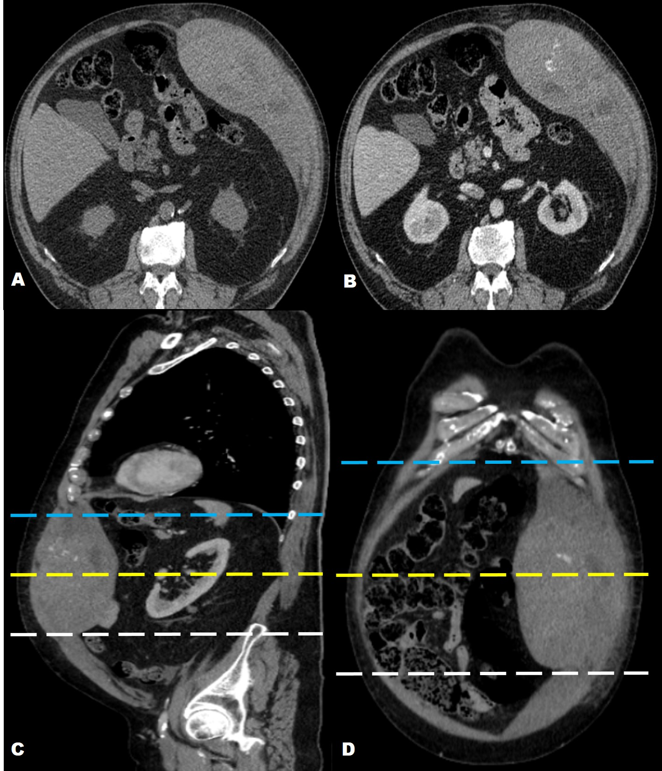
Figure 1: Patient 1. Non-enhanced (A) and contrast enhanced (B-D) CT revealing a large, left sided spontaneously hyperdense rectus sheath hematoma (A), with areas of low attenuation and active contrast extravasation (B-D). It´s extension on the left abdominal wall is clearly depicted on the sagittal (C) and coronal (D) reformats. The area of the hematoma in which active bleeding (B-D) is seen lies above the line (C,D – yellow dashed line) situated midway between the umbilicus (C,D - white dashed line) and the xiphoid process (C,D - blue dashed line), therefore within the superior epigastric artery territory.

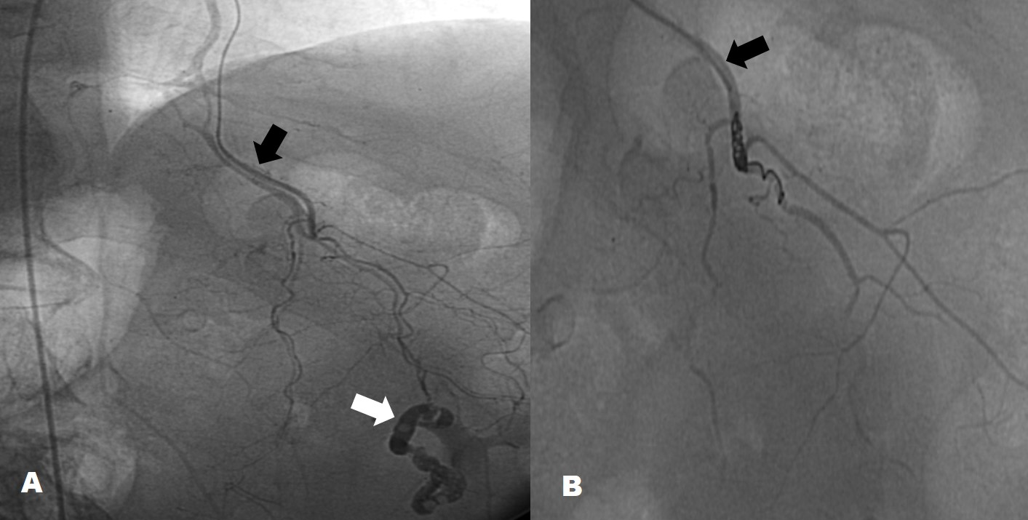
Figure 2. Patient 1. Angiogram following super-selective catheterization of the left superior epigastric artery (A,B-Black arrow), revealing a tubular, tortuouse extravasation of contrast (A- White arrow), closed using coils (B).

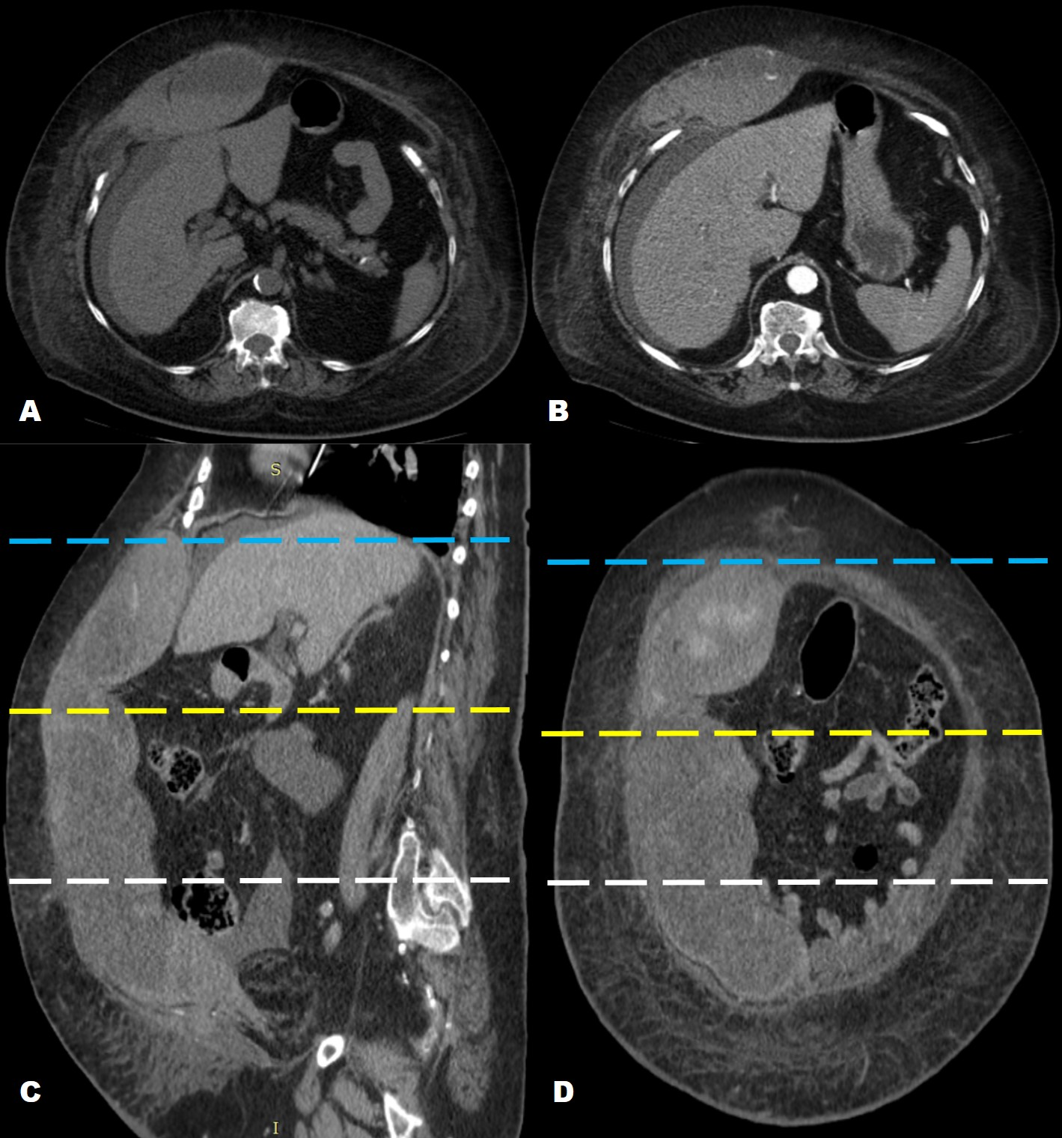
Figure 3. Patient 2. Non-enhanced (A) and contrast enhanced (B-D) CT revealing a right sided rectus sheath hematoma, with a fluid-fluid level (A,B) and several foci of contrast extravasation (B-D) compatible with active bleeding. Sagittal (C) and coronal (D) reformats revealing that the area with active bleeding is located between the xiphoid process (C,D- blue dashed line) and the midline (C,D-yellow dashed line) between the xiphoid process and the umbilicus (C,D white dashed line), therefore within the superior epigastric artery territory.
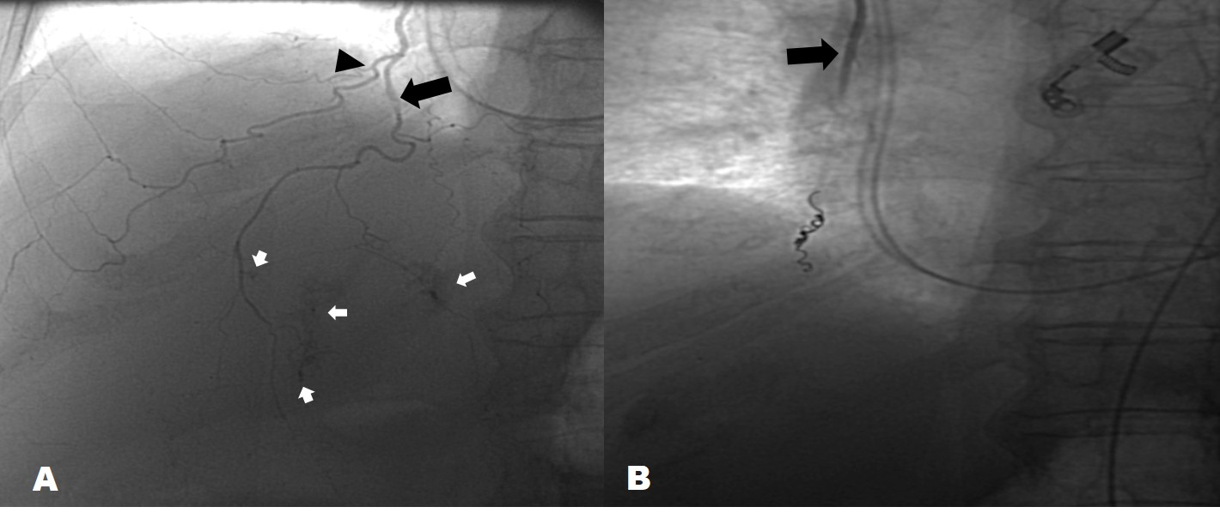
Figure 4. Patient 2. Angiogram following super-selective catheterization of the right superior epigastric artery (A,B-Black arrow) showing multiple foci of active bleading (A-white arrows).Complete exclusion of the bleeding segment (B) following embolization with non-spherical PVA particules and coils. The musculophrenic artery is seen in A (black arrowhead).

