**Título:** Forequarter amputation - extreme surgery, extreme anestesia

**Autores:** Sara Ribeiro, Raul Carvalho

**Instituições:** Centro Hospitalar Universitário do Porto

**Área Terapêutica/Tema:** Anestesia Regional (Regional Anaesthesia)

**Resumo:**

Introduction: Forequarter amputation (FA) is a radical procedure performed for the treatment of malignant tumours of the arm. Perioperative pain management and prevention of phantom limb pain (PLP) are extremely challenging.

Case description: A 58 years-old woman previously submitted to local resection of left proximal humerus chondrosarcoma and total shoulder prosthesis was diagnosed with local progression and pulmonary metastases during the six-month follow-up. Consequently, she was admitted for a FA of the left limb including partial clavicle and scapula resection. Medical history revealed a well-controlled hypothyroidism and depression. The anesthetic plan was a combined anesthesia - general balanced anesthesia with orotracheal intubation followed by a single-shot Interscalene Brachial Plexus Block (IBPB) with 10ml of Ropivacaine 0.375% and Erector Spinae Plane Block (ESPB) at T6 level with 30ml of Ropivacaine 0.5%. The analgesic plan during surgery included fentanyl, dexamethasone, paracetamol and parecoxib administration. The procedure was uneventful. Follow-up included acute pain team daily evaluation. Though stump pain did not occur, at day one after surgery the patient developed painless phantom limb sensations and treatment with pregabalin and amitriptyline was initiated. She was discharged home three days after surgery and referred to chronic pain consultation.

Discussion: The best perioperative analgesic strategy for FA is not clear. We performed a single-shot IBPB and ESPB combined with intravenous conventional analgesia with good perioperative pain control. As the structures innervated by the brachial plexus and part of the brachial plexus itself are removed during surgery, a IBPB alone is thought to be insufficient to achieve adequate perioperative analgesia.1,2 Moreover, IBPB cannot provide anaesthetic coverage of the thoracic dermatomes required for surgery.2 Recently, thoracic ESPB has received attention regarding chronic shoulder pain management and as an alternative for a IBPB for FA since it has been acknowledged that local anaesthetics (LA) can spread to cervical spine nerve roots.3 Thus, we injected a high cephalic orientated volume of LA at T6 level. Maximum recommend doses of LA were calculated. A bolus of 12mg dexamethasone was administered given its analgesic properties and ability to prolong peripheral nerve blocks. Our patient had well controlled pain during the perioperative period but experienced phantom sensations which are common following limb amputation. Close follow-up for development of PLP was made by chronic pain specialists.

Learning points: Perioperative pain management for metastatic chondrosarcoma surgery represents an extreme challenge for the anaesthesia team. PLP remains a concern following limb amputation and should be promptly referred to and adequately treated by chronic pain specialists.

1Can J Anesth 2019; 66:119-20.

2Can J Anesth 2019. DOI: 10.1007/s12630- 019-01421-9.

3Can J Anesth 2018; 65:288-93.

Estudo imagiológico da lesão.

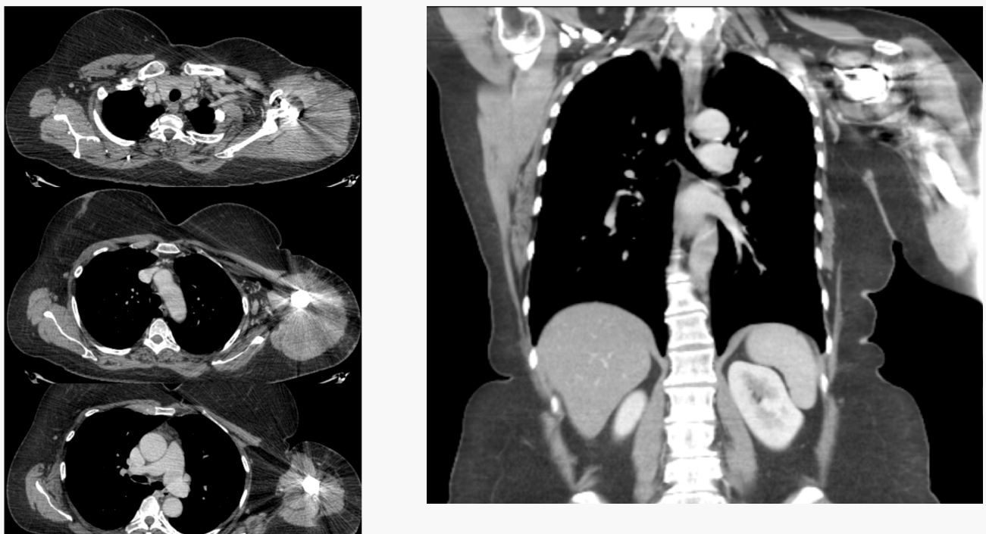

PTO



