**PO29   WHEN THE CONCEPTION OF SYMMETRY DECEIVES US**

Mariana Adams(1); Sónia Macedo Martins Duarte(1); Cristina Peixoto de Sousa(2)

(1) CHUP (2) Centro Hospitalar de Trás-os-Montes e Alto Douro, EPE / Hospital de Vila Real

**Background:** Subclavian artery stenosis (ScAS) is a relatively uncommon (0.5-2%)[1] manifestation of peripheral artery disease (PAD) with significant morbidity. Systolic pressure differences of > 15mmHg can be found in unilateral stenosis as well as a fainter pulse on the affected side. We present a case of a patient with a left subclavian artery stenosis submitted to a non-vascular surgery with a discrepancy of SBP of 100mmHg between limbs.

**Case report:** Seventy-five years-old female patient presented for urgent cemented hip arthroplasty due to left femoral neck fracture. Previously autonomous, ASA PS 4, past medical history of arterial hypertension, non-insulin dependent diabetes mellitus, paroxysmal atrial fibrillation, pulmonary thromboembolism, ischemic heart disease and group 2 pulmonary hypertension, anticoagulated with apixaban. BP readings before surgery were consistently in the 110-125mmHg systolic range in nursery. In the operating room, patient was monitored according to ASA standards, invasive BP, NIRS, processed EEG and hourly urinary output. The initial non-invasive BP reading on the left upper extremity was 117 mmHg systolic. An arterial line was placed on the right radial artery with a systolic reading of 215 mmHg (figure 1). The anesthetic staff compared the amplitude of both radial pulses and observed a clinically relevant asymmetry. BP readings on the lower limbs coincided with the arterial line values on the right radial artery. Control of BP during the procedure was based on arterial line values from thereon out. Previous CT-scan angiography was found to confirm the diagnosis of left subclavian artery stenosis of atherosclerotic nature (figure 2). After adequate monitoring, a combined anesthesia was performed, with a femoral and a lateral femoral cutaneous block and a general balanced anesthesia. Procedure and immediate postoperative period in the intermediate care unit occurred without complications. On day 6 post-op the patient presented a grade 3 left arm hemiparesis and was diagnosed with right lacunar ACM infarct. At the time of submission of this report, the patient had started physiotherapy with improvement of motor deficit.

**Discussion:** Subclavian artery stenosis has a reported incidence of between 0.5 to 2% but in patients with lower extremity arterial disease, this percentage can rise to 9%. The major cause of ScAS is atherosclerotic disease. Clinical manifestations vary according to anatomic factors such as the degree of narrowing, the etiology of the stenosis and the presence of arterial disease in other territories. As an ASA standard for basic anesthetic monitoring, blood pressure determination is an essential tool to access the patient’s circulatory status. Bilateral non-invasive brachial BP determinations should be performed to screen for asymmetry suggestive of stenotic changes to ensure that the readings obtained reflect systemic pressure.

**Bibliography:** 1) Eur J Vasc Endovasc Surg. 2018; 55: 305–368

Figure 1: Graph of BP and heart rate tendencies in the operating room. NIBP-LUL: non-invasive bloop pressure reading on the left upper limb. IBP-RUL: invasive blood pressure monitoring in the right upper limb through a radial arterial line. NIBP - LLL: non-invasive blood pressure reading on the left lower limb

Figure 2: CT-scan angiography of the supra-aortic arch: calcification visible at the emergence of the left subclavian artery. ScA: left subclavian artery. Ao: aorta. RPA: right pulmonary artery. LPA: left pulmonar artery

WHEN THE CONCEPTION OF SYMMETRY DECEIVES US .docx  
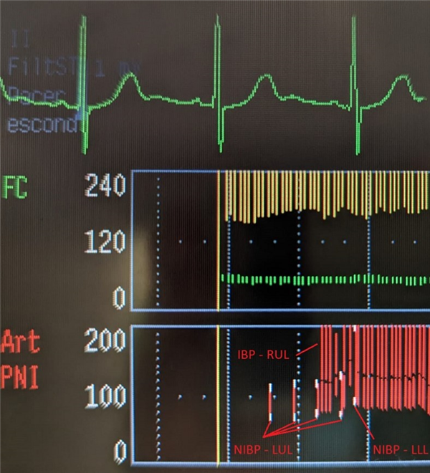  
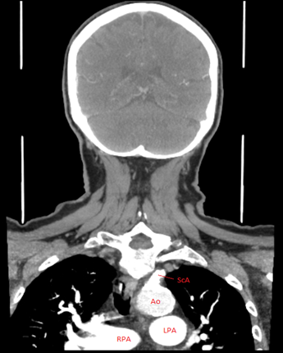

**PO30**