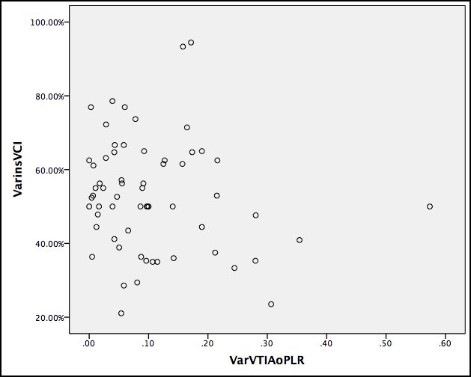

Figure 1 – Scatter plot evidencing the relationship between inspiratory variation of IVC (inspiratory collapse – VarinsVCI) and aortic VTI variation with the PLR manoeuvre (VarVTIAoPLR).