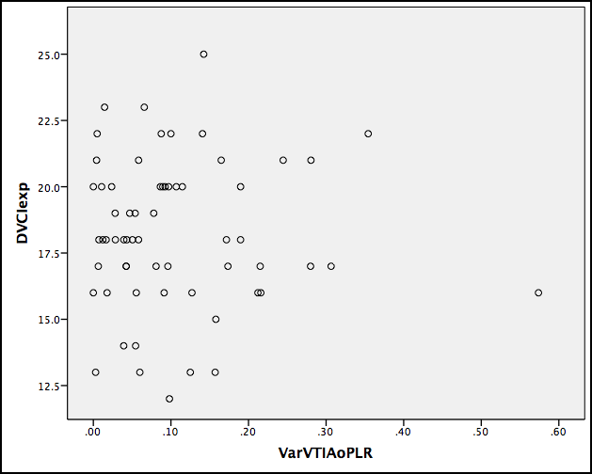
Figure 2 – Scatter plot evidencing the relationship between the expiratory dimension of the IVC (DVCIexp) and aortic VTI variation with the PLR manoeuvre (VarVTIAoPLR).

