Figure 1. Socio-territorial Typology for the Lisbon Metropolitan Area

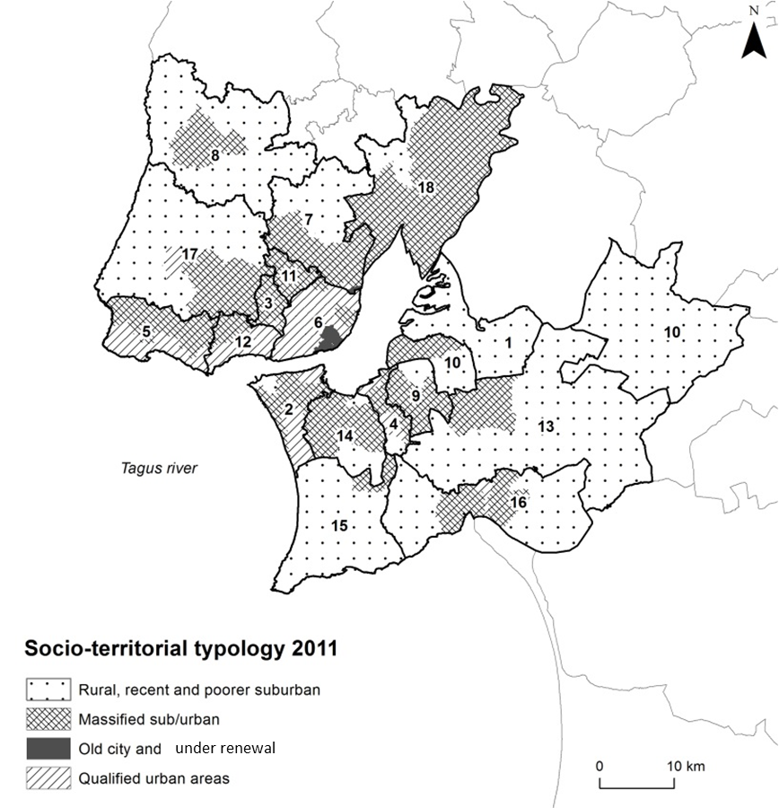
1- Alcochete; 2- Almada; 3- Amadora; 4- Barreiro; 5- Cascais; 6- Lisbon; 7- Loures; 8- Mafra; 9- Moita; 10- Montijo; 11- Odivelas; 12- Oeiras; 13- Palmela; 14- Seixal; 15- Sesimbra; 16- Setúbal; 17- Sintra; 18- Vila Franca de Xira

