Figure 2. Main means of travel.
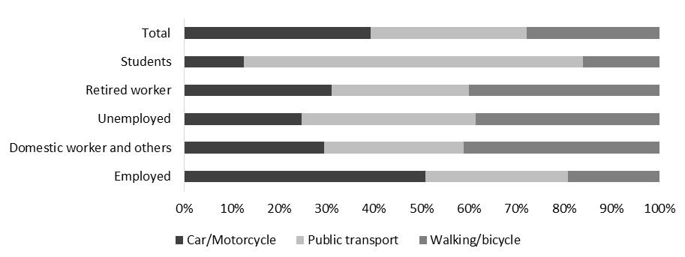
Source: Localways Survey, 2014

