Figure 3. Reason for choice of means of travel

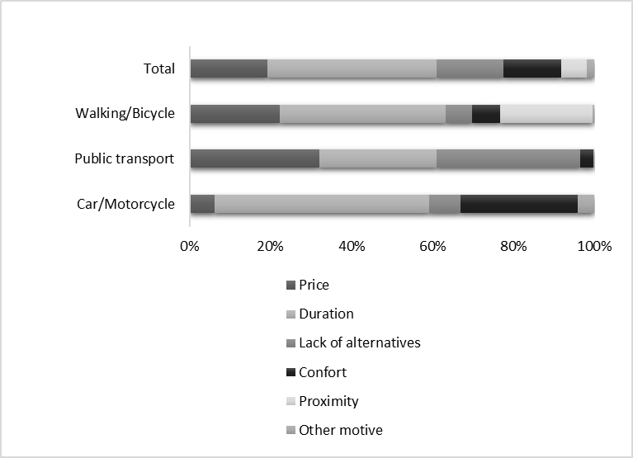
Source: Localways Survey 2014

χ² (10)= 708,821, p<0,001; Cramer’s V 0.482

