Figure 4. Average monthly expenditure on transport per household (euros).
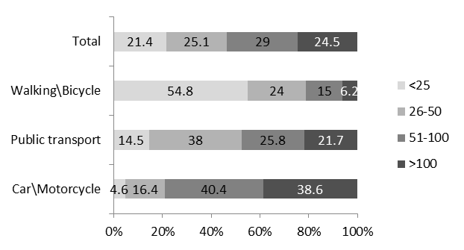
Source: Localways Survey 2014

χ² (6)= 443,347, p<0.001; Cramer’s V 0.414

