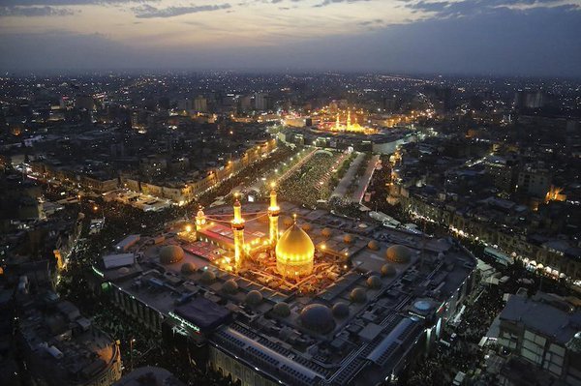

Fonte: [scoopnest.com](http://www.scoopnest.com/user/TheIraqPulse/545239535248875520)

Fig.1- Santuário Imam Al Hussein e Imam Al Abbas, Karbala, Iraque.

*Fig.2- Al Hussein and Al Abbas Shrine, Karbala, Iraq*