Fig. 1 – Da sociedade de consumo à cultura e ecologia do consumo
Fig.1 - From the consumer society to culture and ecology of consumption

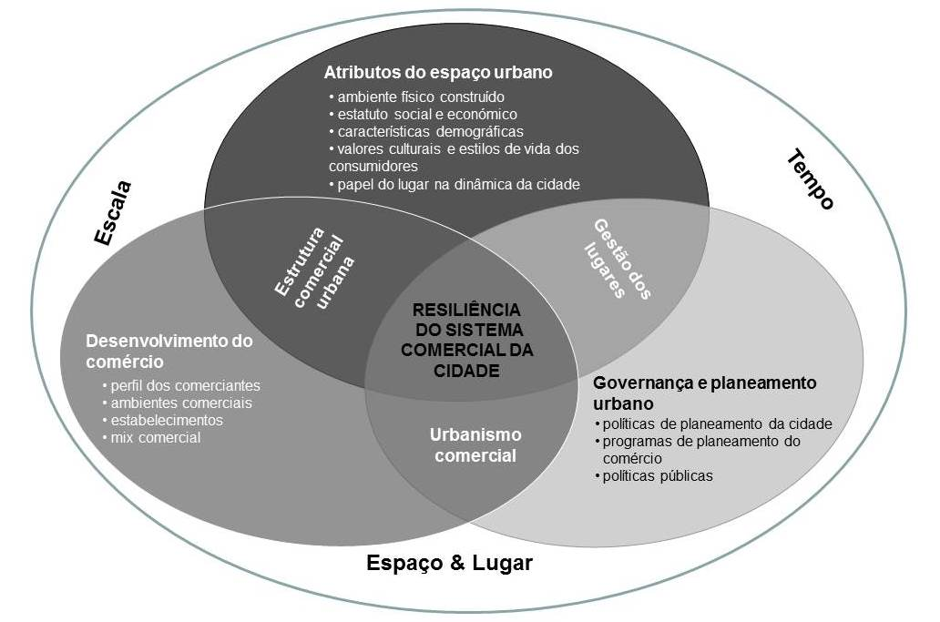

Fig.2 – Quadro conceptual para avaliar a resiliência dos sistemas comerciais urbanos
Figura 2 – Quadro conceptual para avaliar a resiliência dos sistemas comerciais urbanos
Figura 2 – Quadro conceptual para avaliar a resiliência dos sistemas comerciais urbanos
Fig. 2 – Conceptual framework to evaluate the resilience of urban retail systems

