DISASTER MAPPING:
A FORENSIC-GEOGRAPHIC PERSPECTIVE ON THE ROOT CAUSES AND DRIVERS OF DISASTER RISK

Irasema Alcántara-Ayala

ABSTRACT – This article advances a forensic-geographic perspective on disaster mapping, emphasising the need to move beyond hazard-based representations toward uncovering the structural, spatial, and historical causes of disaster risk. Drawing on the principles of the Forensic Investigations of Disasters (FORIN) framework and critical geographic thought, it conceptualises mapping as an epistemological and political tool for diagnosing risk creation over time. Methodologically, the approach integrates multiscale spatial analysis, historical reconstruction, participatory methods, and diverse data sources – from institutional archives and satellite imagery to community testimonies and media discourses. Forensic-geographic mapping reveals latent vulnerabilities, governance failures, and interdependencies that conventional risk maps often obscure. It supports more reflexive, inclusive, and justice-oriented forms of disaster risk reduction by visualising causality and enabling grounded policy interventions. The paper discusses this approach's methodological challenges and transformative potential in advancing critical scholarship and systemic risk governance.

Keywords: Forensic mapping; disaster risk reduction; vulnerability and governance; critical geography; causal risk analysis.

RESUMO – CARTOGRAFIA DOS DESASTRES: UMA PERSPETIVA FORENSE-GEOGRÁFICA SOBRE AS CAUSAS DE FUNDO E OS FATORES MOTRIZES DO RISCO DE DESASTRE. Este artigo desenvolve uma perspetiva forense-geográfica da cartografia de desastres, salientando a necessidade de ir além das representações centradas no perigo para revelar as causas estruturais, espaciais e históricas do risco de desastre. Com base nos princípios da abordagem da Investigação Forense de Catástrofes (FORIN) e no pensamento geográfico crítico, a cartografia é aqui concebida como uma ferramenta epistemológica e política para diagnosticar a produção de risco ao longo do tempo. Metodologicamente, a abordagem integra análise espacial multiescalar, reconstrução histórica, métodos participativos e diversas fontes de dados – desde arquivos institucionais e imagens de satélite até testemunhos comunitários e discursos mediáticos. A cartografia forense-geográfica revela vulnerabilidades latentes, falhas de governação e interdependências que os mapas de risco convencionais frequentemente ocultam. Esta abordagem apoia formas de redução do risco de desastre mais reflexivas, inclusivas e orientadas para a justiça, ao tornar visível a causalidade e ao permitir intervenções políticas informadas. O artigo conclui com uma discussão sobre os desafios metodológicos e o potencial transformador desta abordagem no avanço do conhecimento crítico e da governação sistémica do risco.

Palavras-chave: Cartografia forense, redução do risco de desastre, vulnerabilidade e governança, geografia crítica, análise causal do risco.

HIGHLIGHTS

- Uncovers root causes of disaster risk through forensic-geographic mapping
- Integrates spatial, historical, and participatory data for risk analysis
- Challenges hazard-centric approaches with structural and systemic insights
- Visualises hidden vulnerabilities and governance failures over time
- Supports justice-oriented and transformative disaster risk reduction strategies

- INTRODUCTION

The increasing frequency, severity, and complexity of disasters worldwide have brought renewed urgency to the need for more comprehensive and critical approaches to understanding disaster risk (Wisner et al., 2025). While considerable advances have been made in hazard monitoring, early warning systems, and emergency response planning, the prevailing modes of disaster mapping remain limited in their scope. Most conventional mapping practices delineate hazard zones (De Moel et al., 2009) or document the spatial extent of disaster risk or impacts (Maantay & Maroko, 2009). Although such representations are indispensable for operational purposes, they frequently overlook the broader structural conditions that give rise to risk in the first place (Ackermann et al., 2014). As a result, disaster risk is often portrayed as the outcome of isolated natural events, rather than as the product of systemic processes embedded in socio-political, economic, and spatial dynamics (Lavell & Maskrey, 2014; Maskrey et al., 2023).
In response to these limitations, critical disaster scholarship has increasingly emphasised the socially constructed nature of disaster risk (Blaikie et al., 2014; Oliver-Smith et al., 2016, 2017). Far from being external shocks, disasters are now widely recognised as manifestations of historically and spatially accumulated vulnerabilities, shaped by unequal power relations, land use transformations, institutional failures, and unsustainable development trajectories (Bankoff et al., 2013; Blaikie et al., 2014; Wisner et al., 2025). This epistemological shift calls for a corresponding transformation in how risk is conceptualised, analysed, and communicated, particularly through mapping. Disaster maps must evolve beyond event-focused representations to encompass the deeper causal structures and interdependencies determining how and why specific populations, territories, and systems are disproportionately exposed to harm.
This article advances the argument that a forensic-geographic perspective offers a robust framework for rethinking the practice of disaster mapping. Anchored in the principles of forensic disaster investigations, especially those articulated by the Forensic Investigations of Disasters (FORIN) (Burton, 2010; Oliver-Smith et al., 2016, 2017) initiative, this perspective seeks to uncover the root causes and dynamic drivers of risk by integrating geographic analysis with historical reconstruction, political economy, and institutional critique. Rather than treating maps as neutral technical outputs, the forensic-geographic approach recognises them as instruments of inquiry capable of revealing the spatial and temporal dimensions of risk production.
Through this lens, mapping traces where disasters occur and how risk is configured across scales, shaped by policy decisions, land tenure systems, economic pressures, and environmental transformations (Smith et al., 2023; Wisner et al., 2025). It allows for identifying risk trajectories and visualising slow-onset or latent processes that may not be immediately perceptible in the aftermath of a disaster. This contributes to a more grounded, justice-oriented understanding of disaster risk that can support more inclusive and transformative strategies for risk reduction and resilience building.
To this end, the paper addresses two interrelated questions: What are the conceptual and methodological foundations of forensic-geographic disaster mapping? And how can this approach be operationalised to inform the spatialised production and distribution of disaster risk? The discussion unfolds as follows. The next section outlines this perspective's theoretical and conceptual foundations, situating it within broader critical disaster studies, geography, and risk analysis debates. This is followed by a methodological section detailing the key principles, tools, and data sources that support forensic-geographic inquiry. The fourth section explores this approach's analytical contributions and practical applications, including its capacity to reveal hidden or systemic drivers of disaster risk. The final sections offer a critical discussion of its implications for scholarship, policy, and practice, followed by concluding reflections on future directions for research and action.

- THEORETICAL AND CONCEPTUAL FRAMEWORK

Understanding disaster risk as a socially and historically constructed process requires a shift in theoretical and methodological approaches (Oliver-Smith, 1996; McGowran & Donovan, 2021). Traditional frameworks rooted in hazard-centric paradigms have dominated disaster studies, framing disasters as exceptional events triggered by natural forces and managed primarily through technological and emergency interventions (Alcántara-Ayala et al., 2023). While still prevalent in practice, this perspective has been extensively challenged by critical scholars who emphasise the importance of structural vulnerability, social inequality, and the long-term production of risk (Oliver-Smith et al., 2016). This section discusses a forensic-geographic approach to disaster mapping by engaging three interrelated thought: the evolution of disaster risk paradigms, the principles of forensic investigations of disasters, and the spatial-political dimensions of risk production.

  - From Hazard to Risk Creation: Evolving Paradigms in Disaster Studies

The conceptual evolution from a hazard-centred to a vulnerability-based understanding of disasters has been a defining feature of critical disaster studies over the past four decades. Early models – such as the Pressure and Release (PAR) and Access models (Blaikie et al., 2014; Wisner et al., 2025) – highlighted the layered and root causes of vulnerability, linking disasters to long-standing social, economic, and political conditions. These frameworks departed from technical hazard assessments by foregrounding how systemic inequalities, weak institutions, and marginalisation patterns condition exposure and reduce adaptive capacity (Wisner & Alcántara-Ayala, 2023).
Recognising that disasters are not ‘natural’ but constructed within specific social and territorial contexts has profound implications for how risk is studied. It calls for a deeper engagement with the processes that generate risk, including policy failures, land use decisions, environmental degradation, and the spatial unevenness of development, resulting from accumulated and invisible risk trajectories underpins the need for a forensic-geographic perspective capable of uncovering these latent dynamics.

  - The Forensic Approach to Disaster Risk: Principles and Contributions

The forensic perspective emerged in response to the need for more systematic explanations of disaster causation, particularly in contexts where high-impact events were followed by limited institutional learning or accountability. The Forensic Investigations of Disasters (FORIN) initiative, launched by the Integrated Research on Disaster Risk programme, proposed a structured methodology to investigate the conditions that led to disaster, with an emphasis on causality, temporal sequencing, and the interaction of multiple drivers (Burton, 2010; Oliver-Smith et al., 2016, 2017).
FORIN’s approach rests on the premise that disasters are not isolated incidents but outcomes of complex causal chains involving historical legacies, governance arrangements, social exclusions, and environmental interactions. These investigations prioritise depth over immediacy, seeking to identify the configurations of risk that precede and amplify hazard impacts (Burton, 2010; Oliver-Smith et al., 2016, 2017) (fig. 1). Importantly, FORIN can use diverse methods – including historical analysis, actor mapping, and institutional diagnostics – aligning well with geographic inquiry. The forensic approach thus provides a conceptual and methodological bridge for integrating spatial analysis into explaining disaster causation, tracing the progression from root causes and risk drivers to conditions of exposure and vulnerability, identifying immediate or critical causes and the triggering event to uncover the whole causal chain of disasters.
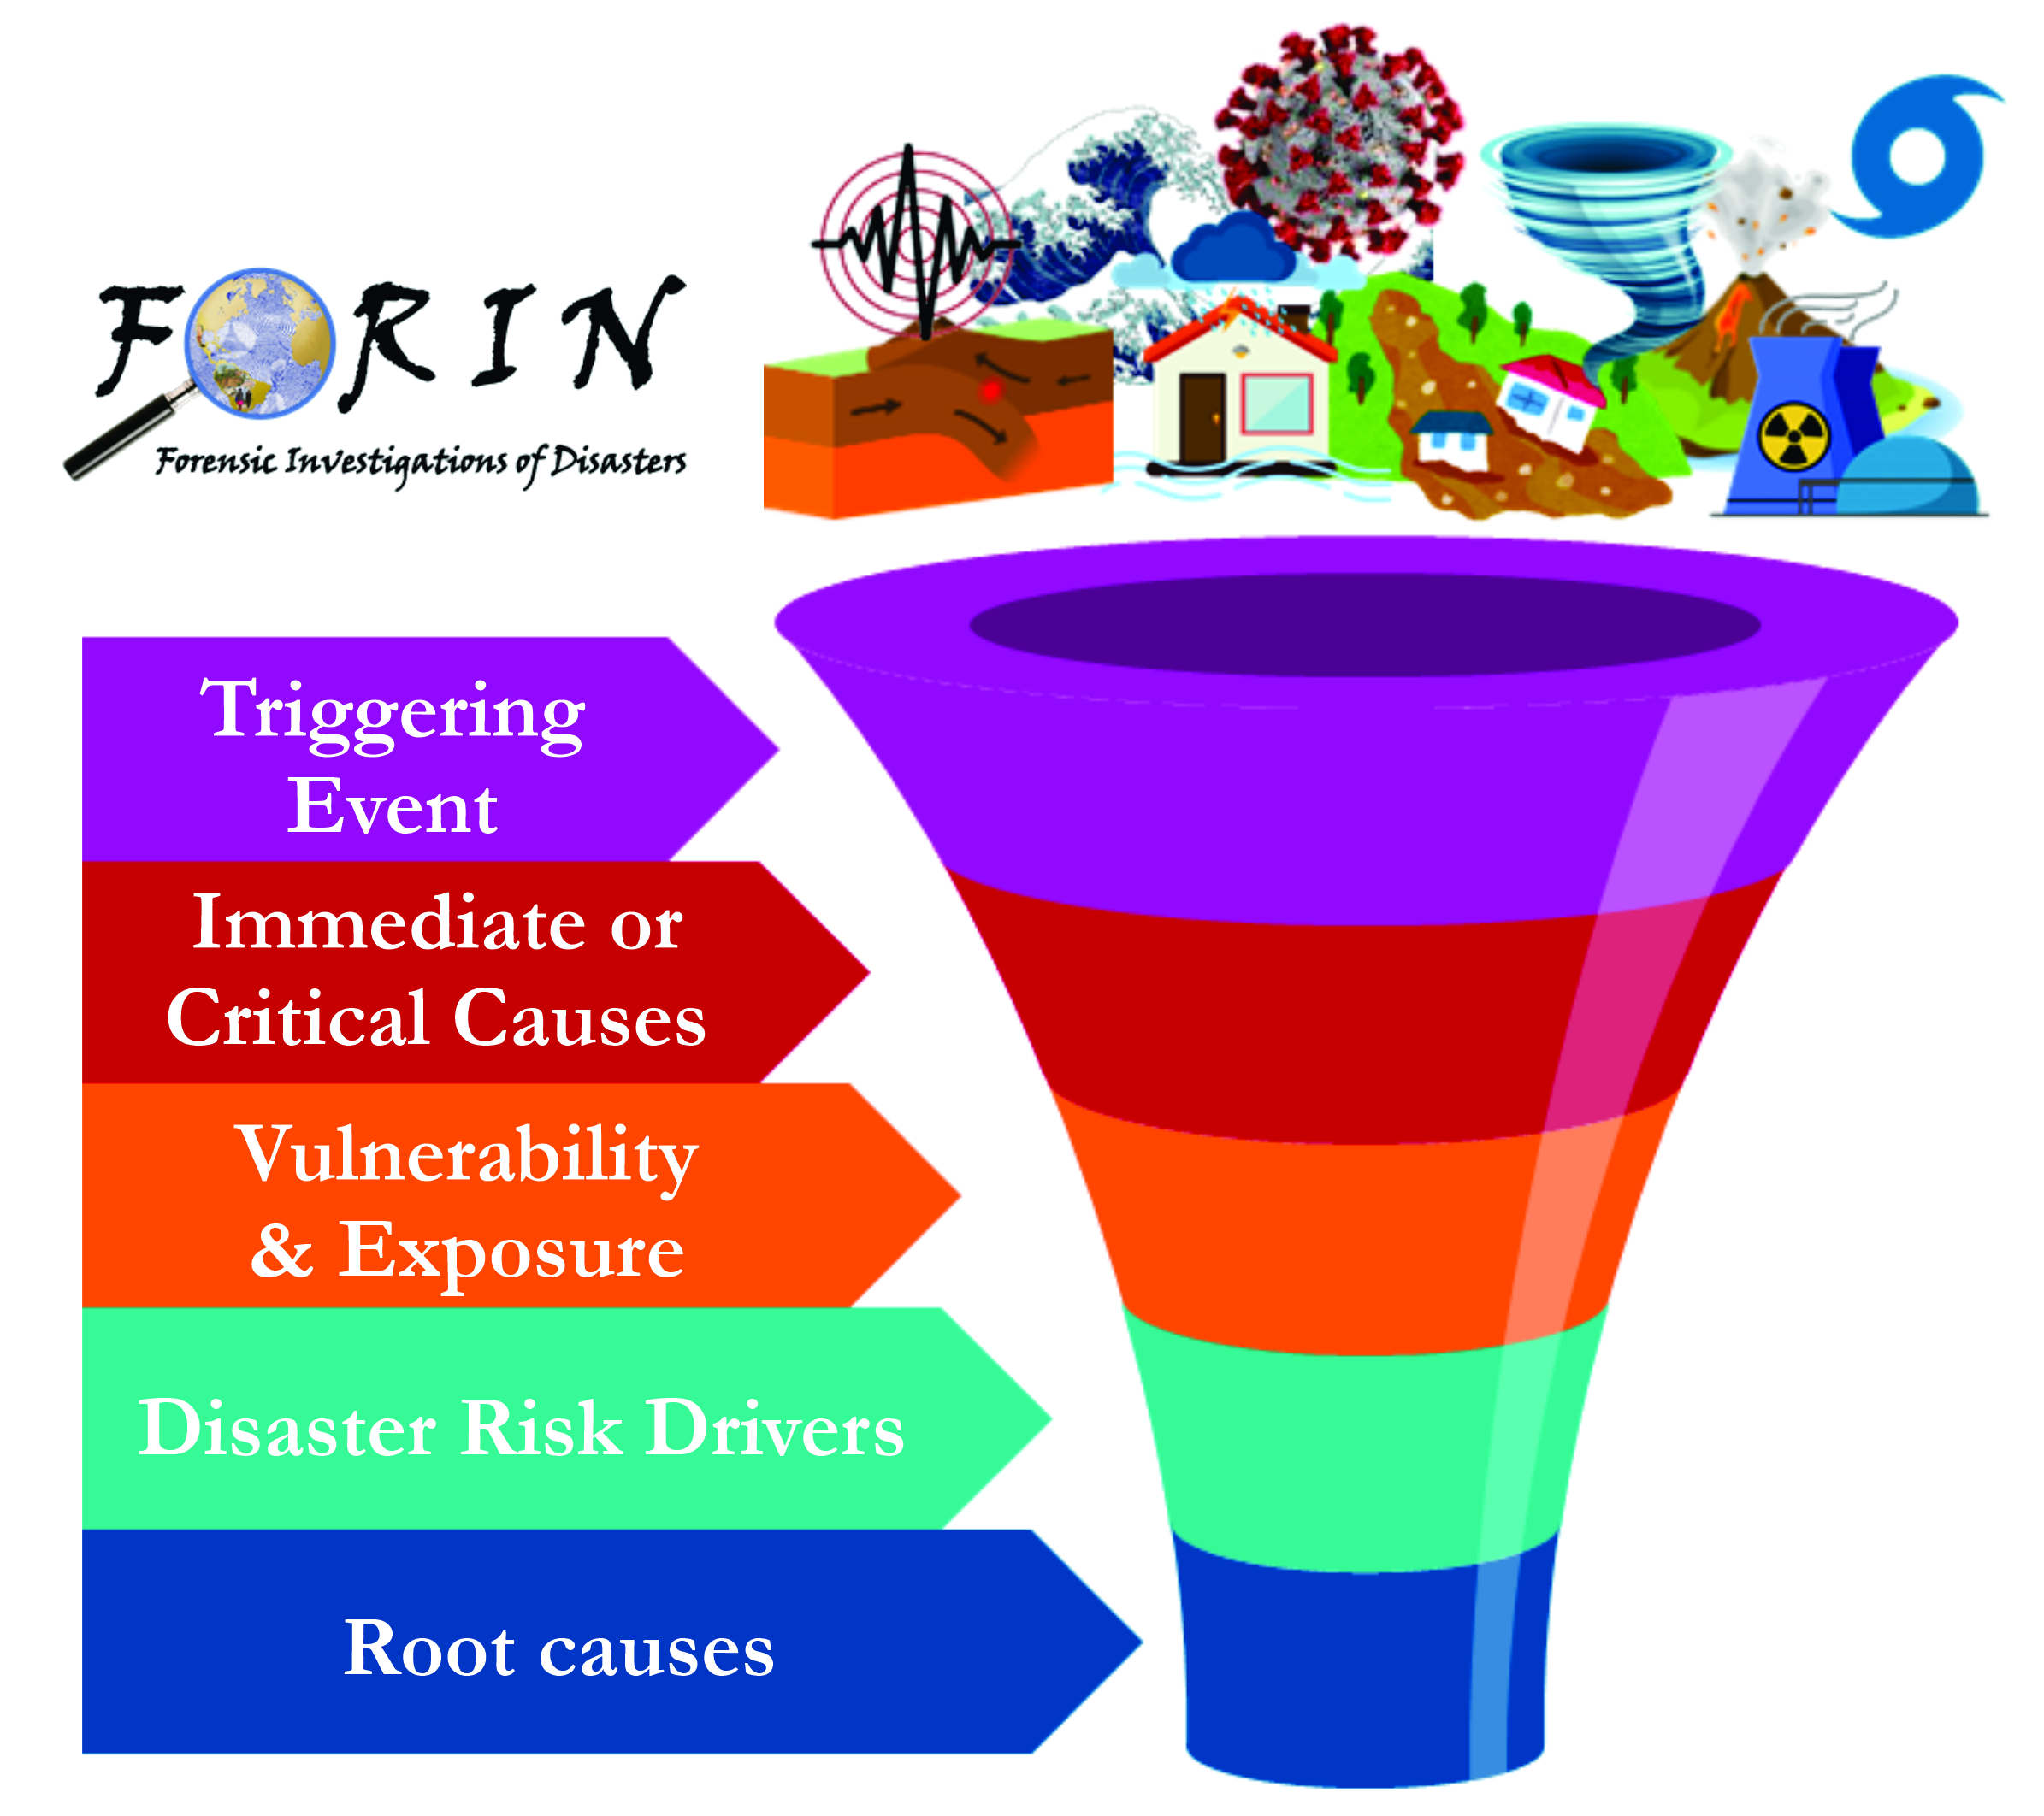
Fig. 1 – Key analytical dimensions of the FORIN approach.
Fig. 1 – Principais dimensões analíticas da abordagem FORIN.
Source: Forensic Investigations of Disasters

  - Geography, Spatial Justice, and the Politics of Risk

Geography, a discipline deeply concerned with spatial relations, territorial dynamics, and human-environment interactions, offers essential tools and perspectives for forensic disaster analysis (Zimmerer, 2017). Spatial justice – the equitable distribution of risks, resources, and decision-making power across space – has emerged as a central concern in geographic debates about urbanisation, development, and environmental governance (Walker, 2009). Disasters often make visible the spatialised nature of injustice: informal settlements on unstable slopes (Alcántara-Ayala, 2025), flood-prone areas occupied by the poor, and infrastructure deficits concentrated in peripheral zones.
A forensic-geographic perspective builds on this tradition by foregrounding how space is not merely a backdrop to disaster but an active dimension in the production of risk. It examines how territorial planning, infrastructure development, environmental management, and land tenure regimes shape patterns of vulnerability and resilience. Moreover, it interrogates the uneven geographies of risk creation, revealing how risk is often displaced, externalised, or rendered invisible through political and economic processes (Beck, 2009; Adam & Van Loon, 2000).
In this context, mapping becomes a technical exercise and a form of critical inquiry – a means to visualise and challenge the power relations and decisions that generate unsafe conditions. Integrating the spatial and the forensic, this approach offers a more comprehensive and justice-oriented understanding of disaster risk, which is attentive to structure and agency, history and geography, evidence and ethics.

- METHODOLOGICAL FOUNDATIONS OF FORENSIC-GEOGRAPHIC MAPPING

Building on the theoretical insights outlined in the previous section, this part elaborates on the methodological underpinnings of a forensic-geographic approach to disaster mapping. In contrast to conventional cartographic practices that prioritise the spatial representation of hazards or the visualisation of post-disaster impacts, forensic-geographic mapping seeks to uncover the deeper causal structures and systemic conditions that generate disaster risk (Lavell & Maskrey, 2014; Maskrey et al., 2023). It relies on a multi-method, multi-scalar, and temporally sensitive methodology that integrates spatial analysis with historical reconstruction, political economy, and institutional diagnostics. This section outlines the key methodological principles, data sources, tools, and ethical considerations that inform this approach.

  - Principles of Forensic Spatial Inquiry

Forensic-geographic mapping is grounded in the principle that disaster risk is produced rather than given. This premise requires methods to identify the spatial distribution of vulnerability and exposure and how these conditions are constructed over time and across multiple scales (Adger, 2006). Methodologically, this entails four interrelated commitments that inform the design and application of forensic-geographic inquiry.
First, multiscale analysis recognises that disaster risk is embedded in dynamics operating at various spatial and institutional levels – local, regional, national, and global. Forensic-geographic mapping seeks to trace the connections between land use changes observed in specific territories and broader processes such as development policies, economic restructuring, or governance reforms that shape risk landscapes.
Second, historical reconstruction is essential to understanding present-day risk. A temporal lens is required to uncover how past decisions, policy failures, and infrastructural trajectories have contributed to the accumulation of vulnerability. This involves using historical timelines, institutional memory, and archival cartography to document the genealogy of risk and reveal long-term patterns that may otherwise remain obscured.
Third, the principle of layered causality and feedback loops reflects the complexity of disaster risk. Rarely the result of a single cause, risk emerges from the interaction of multiple drivers, including environmental degradation, insecure land tenure, socio-spatial inequality, and fragmented governance structures. Forensic mapping seeks to identify these interacting factors and examine how they reinforce or intensify one another across time and space.
Finally, context-specific inquiry underscores the need for methodological flexibility and situated analysis. There is no universal model for forensic-geographic mapping; each context demands an approach tailored to its unique socio-political, ecological, and institutional characteristics. Such inquiry must be informed by technical expertise and grounded local knowledge, ensuring relevance, sensitivity, and analytical depth.

  - Data Types and Sources

Forensic-geographic mapping relies on diverse data that captures disaster risk's spatial, temporal, institutional, and experiential dimensions. These data are not merely technical artefacts but embedded in epistemologies, worldviews, and power relations. Consequently, their selection and interpretation must be methodologically rigorous and reflexively aware. A key premise of this approach is that disaster risk cannot be understood without accounting for the historical processes and situated experiences that have shaped it (Oliver-Smith, 1996). In this context, historical data, including multiple voices, particularly those of affected communities, are essential to reconstructing the causal landscape of disasters (fig. 2).

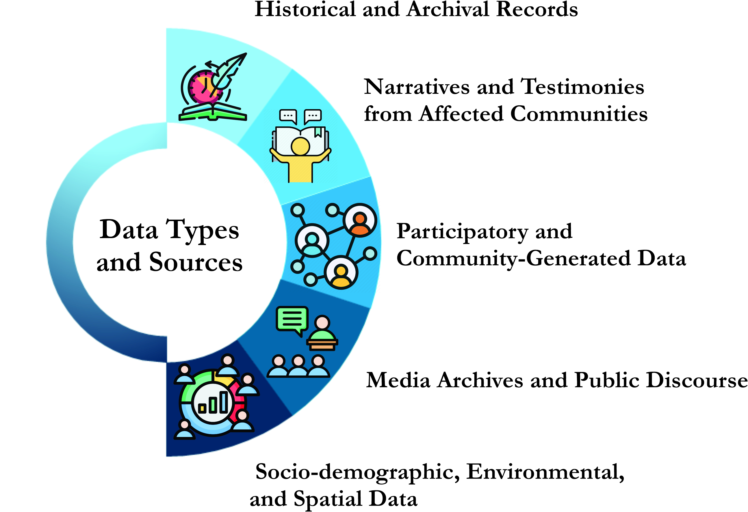

Fig. 2 - Key data sources and knowledge domains informing forensic-geographic disaster risk mapping.
Fig. 2 - Principais fontes de dados e domínios de conhecimento que informam o mapeamento geográfico e forense de riscos de desastres.
Source: Own elaboration

    - Historical and Archival Records

Documenting the genealogy of disaster risk requires close engagement with historical and archival materials revealing past decisions, socio-environmental transformations, and institutional arrangements. These sources are essential for tracing the long-term processes that shape vulnerability and identifying the underlying conditions that give rise to disaster risk.
Historical maps and cadastral surveys provide valuable evidence of changes in land use, patterns of urban expansion, and environmental modifications such as reforestation or deforestation. These spatial records allow for visualising territorial transformations that may have increased exposure to hazards or disrupted ecological buffers.
Urban development plans, zoning regulations, and environmental impact assessments offer further insight into how risk was configured – or overlooked – within formal planning and regulatory frameworks (Dickson et al., 2012). These documents can reveal whether decision-makers anticipated hazard exposure or whether vulnerable populations were systematically located in unsafe areas due to neglect, exclusion, or economic pressures.
Legal and institutional records, including property disputes, water management policies, and shifting mandates of disaster risk governance bodies, shed light on the contested and evolving nature of territorial control and regulatory responsibility. They help to expose institutional discontinuities, fragmentation, and conflicts that may have undermined effective risk management.
Municipal archives also hold crucial information, including council meeting minutes, civil protection protocols, and infrastructure-related budgetary allocations. These materials document the extent to which risk reduction was prioritised – or marginalised – within local governance processes and can reveal critical gaps in planning, preparedness, and institutional accountability.
Taken together, these historical and archival sources support the reconstruction of long-term trajectories of risk accumulation. They provide essential evidence for identifying the structural, institutional, and policy-related failures – or deliberate omissions – that have contributed to the creation and persistence of disaster vulnerability.

    - Narratives and Testimonies from Affected Communities

Equally significant to the forensic-geographic approach is the inclusion of lived experiences and diverse accounts of past disasters (Kelman et al., 2016). Communities affected by such events often possess rich, situated knowledge of the conditions that rendered them vulnerable, the shortcomings of institutional responses, and the adaptive strategies they have developed. These perspectives – elicited through oral histories, ethnographic interviews, storytelling, and community-based memory initiatives – offer critical insights that are frequently absent from, or actively marginalised within, official narratives and documentary records (Alcántara-Ayala et al., 2023).
Incorporating these narratives allows researchers to juxtapose institutional explanations with local understandings of causality and accountability. It also enables the identification of neglected or suppressed claims, such as long-standing demands for infrastructure, protective measures, or legal recognition. Furthermore, it highlights disaster's affective and symbolic dimensions – experiences of loss, displacement, trauma, and memory – often overlooked in technocratic analyses.
By foregrounding these perspectives, forensic-geographic mapping reframes local actors not as passive victims of disaster, but as active knowledge holders and co-producers of insight into the processes that generate and sustain risk. Doing so contributes to a more inclusive and socially grounded understanding of disaster causation.

    - Participatory and Community-Generated Data

A fundamental tenet of the forensic-geographic approach is recognising that disaster risk is experienced and understood differently across social groups, and that any serious investigation into its root causes must engage with these diverse perspectives. To this end, the approach incorporates a range of participatory methods designed to recover, represent, and validate community-based knowledge systematically. These methods provide access to situated understandings of vulnerability and exposure and contribute to the co-production of spatial information grounded in lived realities rather than externally imposed frameworks.
Community mapping and participatory Geographic Information Systems (GIS) are central tools (Gaillard et al., 2015). They enable local residents to visualise, describe, and annotate areas of perceived risk, past hazard events, unsafe infrastructure, or environmental degradation. These mappings often reveal knowledge either absent from official datasets or differently prioritised by institutions, such as informal networks of evacuation routes, flood-prone footpaths, or locations of failed mitigation efforts.
Complementing these tools are participatory timeline exercises (Bustillos Ardaya et al., 2018), which support the reconstruction of key historical events, policy interventions, or environmental changes that community members remember. These temporal narratives shed light on the sequence and interplay of actions and omissions contributing to risk accumulation. They also reveal collective memory, trauma, and resilience patterns critical for understanding how disasters are embedded in everyday life.
In addition, focus group discussions and transect walks facilitate more dynamic and dialogical forms of engagement (Ahmed & Kelman, 2018), articulating collective interpretations of vulnerability, resource access, institutional trust, and capacities for self-organisation. These encounters often reveal contradictions, contested narratives, or internal differences within communities, reminding researchers that local knowledge is not monolithic but situated, negotiated, and sometimes unevenly distributed.
Together, these participatory methods foster what can be described as horizontal knowledge production (Manuel-Navarrete et al., 2021). They create spaces where communities are not merely consulted but actively engaged as collaborators in identifying, analysing, and visualising disaster risk. In doing so, they enhance mapping outputs' legitimacy, relevance, and social accountability, reflecting local priorities and epistemologies. Crucially, they help prevent the reproduction of top-down cartographic practices that risk silencing or misrepresenting those most affected by disaster.
In this way, participatory and community-generated data do more than enrich empirical analysis – they reposition mapping as a socially embedded and politically meaningful practice. They allow forensic-geographic investigations to uncover the layered, contested, and place-specific nature of risk, and to do so in ways that support analytical depth and democratic engagement.

    - Media Archives and Public Discourse

Media archives constitute a critical and often underutilised data source for forensic-geographic investigations into disaster risk. Unlike institutional records or technical assessments, media content captures the discursive and symbolic dimensions through which disasters are represented, debated, and made intelligible to the broader public. Analysing such content – from newspaper articles and radio broadcasts to television transcripts and digital platforms – enables researchers to trace how disaster events and their underlying causes are framed, who is held responsible or exonerated, and how different social groups are depicted in moments of crisis.
The media play a central role in shaping public understanding of disasters, influencing not only perceptions of risk but also responses by policymakers and institutions (Miles & Morse, 2007). For example, a critical reading of press coverage may reveal whether narratives focus narrowly on the event itself or extend to structural explanations involving governance failures, socio-spatial inequalities, or environmental degradation. It may also show whose voices are amplified or excluded, whether the experiences of affected communities are foregrounded, marginalised, or instrumentalised in constructing post-disaster discourse (Barnes et al., 2008).
Social media content and digital testimonies have become increasingly relevant in the context of more recent disaster events (Palen & Hughes, 2017). Platforms such as X (former Twitter), Facebook, and WhatsApp serve as tools for communication and mobilisation and as rich sources of real-time data on how populations perceive and respond to unfolding crises. These digital narratives often include expressions of distress, frustration, solidarity, and political critique, and they may document aspects of the disaster that remain unreported in official or mainstream channels.
By examining mainstream and social media content, researchers can identify dominant framings, counter-narratives, and forms of resistance (Amaral, 2021). These may contest official accounts, expose misinformation, or demand accountability for long-standing neglect. As such, media archives contribute to a more contested, plural, and politically situated mapping of disaster causation, reflecting the diversity of interpretations and experiences accompanying any disaster event.
Incorporating media analysis into forensic-geographic mapping strengthens its capacity to engage with the discursive construction of risk, complementing spatial and historical studies with insight into the politics of meaning and representation. It also reinforces the understanding that disasters are not only material phenomena but also communicative events, shaped by and shaping public discourse, institutional legitimacy, and collective memory.

    - Socio-demographic, Environmental, and Spatial Data

The forensic-geographic approach also draws upon a range of conventional datasets essential for the spatial analysis of vulnerability and risk. While often used in technical risk assessments, these datasets gain renewed relevance and interpretive depth when integrated into a framework concerned with the distribution of risk and its historical, structural, and relational construction.
Socio-demographic data, particularly census information disaggregated by income level, gender, ethnicity, housing quality, and access to essential services, provide crucial indicators of differentiated vulnerability (Tate et al., 2021). These data allow for identifying social groups and territories disproportionately exposed to risk due to entrenched inequalities in living conditions and institutional neglect.
Environmental data – encompassing rainfall patterns, soil composition and stability, vegetation cover, and hydrological flows – are equally critical (Van Westen, 2013). They provide insight into the biophysical conditions that shape hazard dynamics and interact with human settlement patterns. When interpreted through a forensic-geographic lens, such data help reveal how environmental degradation, unsustainable land use, and climate variability contribute to long-term risk accumulation.
Remote sensing and satellite imagery are powerful means of detecting landscape changes over time (Franklin et al., 2002). These tools are particularly effective in identifying land cover transitions, urban expansion into hazard-prone areas, deforestation, and the extent of damage following disaster events. Temporal analysis of such imagery can illuminate how risk evolves spatially and reveal the consequences of planning decisions, infrastructural development, or the absence thereof.
Infrastructure and service provision maps further contribute to this analytical framework by exposing spatial inequalities in access to critical systems such as roads, potable water, electricity, healthcare, and education (Dodman et al., 2023). These layers help to identify infrastructural vulnerabilities that may increase exposure or impede recovery, particularly in marginalised areas.
Together, these datasets provide the material substrate for constructing multi-layered spatial analyses that indicate where risk is located and how it is shaped and compounded over time by interacting variables. Their value lies in their quantitative robustness and capacity to be cross-referenced with other forms of data – archival records, community narratives, participatory mappings, and media content – to build a more nuanced and systemic account of disaster risk.
By integrating these varied data sources, the forensic-geographic approach offers a comprehensive and reflexive understanding of vulnerability, restoring visibility to risk dimensions often obscured in conventional hazard-based assessments. It acknowledges all knowledge's partial and situated nature, embracing methodological pluralism to develop a richer, more context-sensitive analysis of disaster causation. It provides an essential corrective to technocratic models and contributes to constructing more just and inclusive frameworks for disaster risk reduction.

  - Tools and Techniques for Mapping Root Causes

A forensic-geographic approach to disaster mapping draws on various analytical tools to investigate the spatial, institutional, and systemic drivers of risk. These tools help visualise complex causal relationships, identify key actors and processes, and examine the multiscale dynamics through which vulnerability is produced and sustained. Their use goes beyond conventional hazard analysis, engaging critically with the spatial dimensions of power, marginalisation, and governance failure.
Geographic Information Systems (GIS) remain a foundational element in this framework but are reconfigured to exceed the confines of hazard and exposure mapping (Van Westen, 2013). Within forensic applications, GIS enables the spatial correlation of vulnerability indicators, integration of historical and environmental data, and modelling of risk trajectories. This supports a more holistic understanding of how socio-environmental and institutional processes converge in the creation of risk.
Temporal mapping and sequence diagrams are equally essential, facilitating the reconstruction of risk chronologies. These visual tools document institutional decisions, regulatory changes, and socio-spatial transformations that drive vulnerability over time. By incorporating time as a key analytical dimension, they capture the cumulative and often delayed effects of structural processes that lead to disaster.
Actor and institutional mapping provide insights into the governance landscape surrounding risk production (Mardiah et al., 2017). This technique highlights key stakeholders, inter-agency dynamics, and points of cooperation or contention. It helps expose institutional fragmentation, overlapping mandates, and asymmetries of power that impede coordinated risk reduction.
The Design Structure Matrix (DSM) (Eppinger & Browning, 2012) is particularly effective for visualising interdependencies among risk drivers by mapping how insecure land tenure, degraded environments, and inadequate infrastructure interact. DSMs support the complexity analysis and reveal the relational architecture of vulnerability.
Finally, critical cartography (Crampton & Krygier, 2005) anchors the epistemological foundations of this approach. Mapping is understood not as a neutral act of representation but as a spatial critique – one capable of challenging dominant narratives, recovering marginalised perspectives, and interrogating the technocratic assumptions that often obscure the root causes of risk.
Crucially, none of these tools is neutral. Their application requires methodological reflexivity and an acute awareness of the assumptions and power relations they may reinforce or challenge. The forensic-geographic approach demands a commitment to transparency, inclusivity, and accountability in analytical practice and knowledge's visual production.

  - Ethical Considerations in Mapping Risk and Vulnerability

Forensic-geographic mapping entails methodological and analytical decisions and ethical responsibilities (Heesen et al., 2015). Visualising vulnerability, marginalisation, and institutional shortcomings carries significant implications, particularly when maps are used in public discourse, policy-making, or advocacy. The ethical stakes of representing risk are exceptionally high in social inequality, contested governance, or historical neglect. The maps produced through this approach do not merely document spatial realities; they shape how communities are perceived, whose knowledge is legitimised, and which claims are heard or silenced. For this reason, ethical reflexivity must be embedded throughout the research process.
A primary ethical concern is the avoidance of stigmatisation (Kasperson et al., 2012). Maps highlighting risk-prone areas, informal settlements, or institutional failures must not reinforce deficit-based narratives or portray communities as inherently vulnerable or dependent. Such representations can have unintended consequences, including social exclusion, discrimination, or the justification of coercive interventions. Instead, mapping practices should recognise and reflect the agency, resilience, and capacities within at-risk populations.
Informed consent and meaningful participation are equally fundamental (Sarker, 2025). Particularly when engaging in participatory mapping or collecting qualitative data, researchers must ensure that communities retain agency over how their territories, experiences, and knowledge systems are represented. This includes transparent communication about the purpose of the mapping, how the information will be used, and the potential risks associated with public dissemination. Community members should have opportunities to validate, revise, or contest how their realities are visualised.
Another essential consideration is data sensitivity and confidentiality (Sarker, 2025). Forensic-geographic investigations often uncover sensitive issues such as land tenure disputes, informal urbanisation, environmental degradation, or institutional corruption. When such data are mapped, primarily if they circulate beyond academic or community settings, there is a risk of exposing individuals or groups to harm. Researchers must take care to anonymise data where appropriate, obtain explicit permission for publication, and critically assess the potential consequences of visual disclosures.
Ethical mapping requires ongoing reflexivity and awareness of positionality (Jacobson & Mustafa, 2019). Researchers must remain attentive to their roles in shaping risk narratives, the epistemological assumptions they bring to the mapping process, and the power dynamics that structure their engagement with communities. This involves recognising how knowledge is co-produced, whose perspectives are prioritised, and how representational choices may reflect or challenge dominant frameworks.
Integrating these ethical principles into the methodological design can transform forensic-geographic mapping from a purely analytical tool to an instrument of social accountability, epistemic justice, and community empowerment. When conducted responsibly, this approach enhances the rigour and credibility of disaster research and supports more inclusive, respectful, and transformative engagements with risk and vulnerability.

- APPLICATIONS AND ANALYTICAL DIMENSIONS

The forensic-geographic approach to disaster mapping provides a conceptually and methodologically robust framework for investigating the underlying conditions through which disaster risk is generated, sustained, and rendered invisible. It moves beyond static representations that isolate hazards or measure impacts in isolation, instead enabling the spatial and temporal analysis of risk as a dynamic, socially embedded, and historically produced phenomenon. This approach positions mapping as a tool for visualising outcomes and interrogating the socio-political and environmental processes that shape vulnerability and exposure over time and across scales.
A key contribution of this approach lies in its ability to map what is often obscured in conventional disaster representations. These include visible manifestations of risk, such as damaged infrastructure or hazard-prone areas, and root causes and latent conditions that precede disaster events and determine their uneven impacts. In this sense, mapping becomes a diagnostic device for exposing the structural dimensions of risk, including spatial inequalities, institutional vacuums, and development models that externalise environmental and social costs (fig. 3).

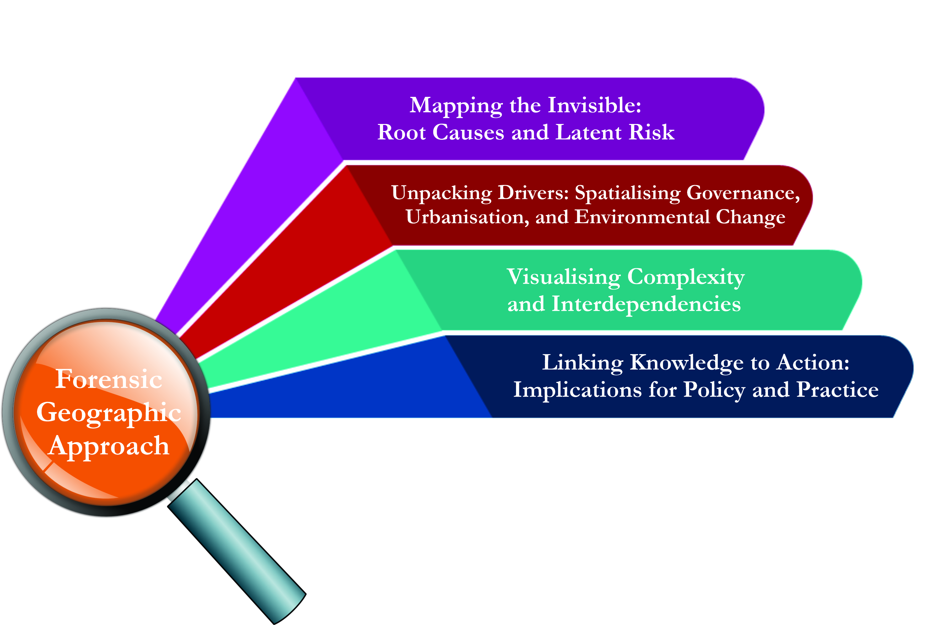
Fig. 3 – Analytical applications and dimensions of the forensic-geographic approach.
Fig. 3 – Aplicações analíticas e dimensões da abordagem forense-geográfica.
Source: Own elaboration

  - Mapping the Invisible: Root Causes and Latent Risk

Among the most significant analytical strengths of forensic-geographic mapping is its capacity to visualise processes and drivers that remain imperceptible in hazard-centric or post-impact maps. These include embedded vulnerabilities, unresolved institutional deficits, and long-term patterns of socio-environmental degradation that operate across extended temporal horizons. Conventional disaster maps often treat the event as the primary analytical unit – an abrupt rupture to be responded to and measured. In contrast, forensic mapping reconceptualises disaster as the outcome of a continuum of causation, wherein historical legacies, governance failures, and territorial decisions converge to produce risk.
This shift in analytical perspective enables researchers, planners, and policymakers to identify the pre-existing conditions that magnify the severity of disaster impacts. It facilitates the reconstruction of the genealogies of institutional neglect, fragmented governance, and exclusionary urban planning that contribute to the systematic accumulation of risk. Furthermore, it reveals slow-onset and diffuse processes that do not always trigger immediate disasters but degrade resilience over time, such as unchecked deforestation, informal settlement expansion in hazard-prone areas, loss of wetlands and buffers, and the gradual erosion of institutional capacities for regulation and enforcement.
Forensic-geographic mapping strengthens retrospective analysis and prospective risk governance by focusing on these latent and systemic drivers (Renn et al., 2022). It equips decision-makers with tools to anticipate future risk configurations, particularly in contexts undergoing rapid urbanisation, ecological transition, or climate-induced variability. This anticipatory function is essential in settings where the pace of change outstrips the capacity of formal institutions to respond, and where vulnerability is less a result of individual choices than of entrenched structural constraints.
Mapping the invisible is not simply about making risk visible; it is about rendering legible the historical, spatial, and political dynamics through which certain places and populations come to bear the brunt of disaster. Through this analytical lens, the forensic-geographic approach contributes to a more transformative and justice-oriented understanding of disaster risk – one that seeks not only to measure but also to explain, expose, and ultimately reduce the conditions of vulnerability at their source.

  - Unpacking Drivers: Spatialising Governance, Urbanisation, and Environmental Change

Forensic-geographic mapping facilitates a nuanced and multi-layered diagnosis of the spatial production of disaster risk by tracing the interactions between governance, urbanisation, land use, and socio-environmental change. Central to this approach is the recognition that spatial patterns of vulnerability are not natural or inevitable outcomes of environmental processes, but rather the result of political choices, institutional arrangements, and development trajectories that systematically expose specific populations and territories to heightened levels of risk (Blaikie et al., 2014).
This perspective reorients the analytical focus from where disasters happen to how and why risk becomes concentrated in particular locations. It reveals, for example, how land tenure regimes, often shaped by historical exclusions or informal arrangements, can render entire communities legally invisible and therefore unprotected by formal disaster risk reduction efforts. Similarly, it draws attention to the spatial consequences of urbanisation processes, particularly in contexts where rapid growth is unaccompanied by adequate planning, basic services, or environmental safeguards. Informal settlements – frequently situated on floodplains, unstable slopes, or degraded land – exemplify spaces where risk is not simply present but actively produced through neglect, exclusion, and marginalisation patterns.
Infrastructural deficits compound this vulnerability. Forensic-geographic mapping helps to visualise the uneven distribution of essential services such as drainage, water supply, road access, and emergency infrastructure. These disparities often correlate with socio-economic inequalities, reinforcing cycles of exposure and reducing adaptive capacity in already at-risk communities. Moreover, such analysis sheds light on how risk is displaced through urban development schemes or relocation policies that push vulnerable populations into environmentally fragile zones, often under the guise of progress or safety, yet reproducing or even amplifying existing vulnerabilities.
Equally critical is the mapping of governance fragmentation, whereby overlapping mandates, conflicting institutional jurisdictions, or a lack of coordination between agencies result in regulatory blind spots or paralysis in implementing risk reduction measures (Marks & Lebel, 2016). These institutional fractures are spatially expressed in gaps between protected and unprotected areas, hazard zoning inconsistencies, and fragmented early warning or non-resistant infrastructures. Forensic mapping makes these patterns visible, linking them to broader political and administrative power structures that underpin risk production.
The forensic-geographic approach strengthens the analytical bridge between material geographies and the political economy of risk by revealing how spatial arrangements are co-produced by political decisions, economic imperatives, and institutional logics. It enables a critical reading of space not simply as a passive backdrop, but as a dynamic terrain of contestation, negotiation, and structural inequality. In doing so, it contributes to a deeper understanding of how vulnerabilities are embedded within broader urbanisation and environmental change processes, and why certain groups remain persistently exposed to disaster.

  - Visualising Complexity and Interdependencies

Disaster risk is rarely attributable to a single factor or isolated event. It emerges from a constellation of interdependent variables interacting across multiple spatial and temporal scales. These variables – from environmental degradation and infrastructural vulnerabilities to institutional weakness and socio-economic inequality – rarely operate in isolation. Instead, they compound, reinforce, or trigger one another, often in unpredictable ways. A core strength of the forensic-geographic approach lies in its capacity to visualise this complexity, enabling the identification of feedback loops, causal chains, and cascading effects that are often overlooked in linear or sectoral analyses.
Forensic-geographic mapping embraces this complexity by employing tools designed to represent multi-layered and dynamic systems of causation. Among these, Design Structure Matrices (DSM) are particularly valuable, as they allow for systematically analysing interdependencies among risk drivers (Spiekermann et al., 2015). DSMs help reveal how particular factors, such as informal land occupation, deficient infrastructure, and environmental stress, are interconnected and mutually reinforcing. When complemented by temporal layering and network-based mapping, these tools make it possible to visualise how risk evolves, interacts across sectors, and responds to shocks in ways that may not be immediately visible through conventional mapping techniques.
This analytical dimension is particularly salient in compound and cascading disasters, where multiple hazards or failures occur simultaneously or sequentially, producing complex and often disproportionate impacts. Interconnected systems – such as housing, public health, transportation, energy, and ecosystems – can become vulnerable at multiple points, with a disruption in one domain triggering failures in others. For example, a landslide may damage homes, block access roads, cut off water supply infrastructure, and generate secondary displacement or health emergencies.
Through its capacity to trace these cross-sectoral relationships, forensic-geographic mapping provides stakeholders with critical insights into systemic vulnerabilities. It enables decision-makers to understand how small perturbations can escalate into large-scale crises when they affect critical nodes or tipping points within complex systems. This knowledge is instrumental for improving anticipatory governance: by identifying which areas, systems, or institutions are most susceptible to cascading impacts, it becomes possible to design interventions that strengthen resilience at multiple levels.
Moreover, such visualisations foster a more integrated approach to risk management, one that moves beyond hazard silos and single-sector planning. They inform the development of early warning systems, infrastructure investments, and institutional reforms that account for the relational nature of vulnerability. Forensic-geographic mapping supports the design of more robust, adaptive, and context-sensitive efforts to disaster risk reduction capable of addressing the symptoms and the interlocking structures that perpetuate risk across space and time.

  - Linking Knowledge to Action: Implications for Policy and Practice

A central aim of the forensic-geographic approach is to move beyond academic analysis and contribute meaningfully to more inclusive, accountable, and effective disaster risk governance. By revealing the root causes and systemic drivers of vulnerability, this approach seeks to deepen understanding and inform action. In this context, mapping becomes more than a technical or descriptive tool – it is reimagined as a strategic instrument for social transformation, capable of exposing injustice, legitimising claims, and opening political space for dialogue and intervention.
The outputs of forensic-geographic mapping offer multiple entry points for policy and planning processes. First, they can inform risk-sensitive territorial planning by identifying structurally unsafe areas, visualising cumulative vulnerabilities, and supporting land use regulation, zoning, and urban development decisions. Unlike traditional hazard maps, forensic mappings contextualise spatial exposure within historical and socio-political processes, allowing for more grounded and preventative planning.
Second, such mappings can support policy design and reform by providing evidence of institutional dysfunctions, regulatory fragmentation, or implementation gaps. By visualising patterns of neglect, omission, or policy contradiction, they can critique existing governance structures and advocate for reforms that align more closely with the lived realities of at-risk communities.
Third, forensic-geographic mapping can reinforce accountability mechanisms. When used to document failures to act on known risks or to protect vulnerable populations, maps can function as tools for public oversight and advocacy. They provide tangible, spatially anchored evidence that can be mobilised by civil society, media, or legal actors to press for institutional responsibility and redress.
Importantly, mapping also serves as a medium for community empowerment when embedded within participatory processes. It enables affected groups to articulate risk experiences, challenge dominant narratives, and demand structural change. This way, participatory mapping becomes a political agency, bridging grassroots knowledge with institutional dialogue (Boll-Bosse & Hankins, 2018). Moreover, these processes can foster new alliances between researchers, communities, and policy actors, building coalitions committed to socially just and transformative approaches to disaster risk reduction.
Forensic-geographic mapping fundamentally challenges technocratic approaches that reduce risk to abstract indicators or decontextualised models by foregrounding complexity, causality, and spatial justice. Instead, it promotes a conception of disaster risk as historically rooted, politically produced, and spatially manifest, requiring equally systemic and equitable responses. As such, it offers a critical contribution to the realisation of the Sendai Framework for Disaster Risk Reduction and to broader goals of sustainable, inclusive development that centre rights, equity, and accountability.

- DISCUSSION

The preceding analysis demonstrates that forensic-geographic mapping offers a significant departure from conventional approaches to disaster cartography, enabling a deeper interrogation of risk causation and its spatial articulation. By integrating historical, institutional, and lived dimensions of vulnerability, this approach provides an enriched analytical framework capable of uncovering processes of risk creation that are otherwise obscured in hazard-centric paradigms. This discussion reflects on the implications of this perspective for knowledge production, policy engagement, and risk governance, while also considering the methodological and epistemological challenges it entails.

  - Mapping as Method and Critique

Disaster maps are often treated as technical outputs – neutral representations that provide objective evidence of risk or impact. Yet mapping is inherently a political and epistemological act. It involves choices about what to include or exclude, whose knowledge to privilege, and how spatial relationships are interpreted (Kitchin et al., 2013). From a forensic-geographic standpoint, mapping is not simply a method of representation but also a form of critique: it challenges dominant narratives of disaster causation, renders visible the structural and systemic nature of risk, and exposes the spatialised injustices embedded in development trajectories.
This reorientation aligns with critical cartography traditions, which view maps as socially constructed artefacts that reflect and shape power relations. Forensic-geographic mapping builds on this tradition by situating maps within a broader forensic investigation, using them to question the “official” accounts of disaster and uncover suppressed or overlooked explanations. Doing so confronts the depoliticisation of disaster risk and contributes to more reflexive and accountable knowledge production.

  - Towards Transformative Risk Governance

Beyond academic inquiry, forensic-geographic mapping carries significant implications for disaster risk governance. Its emphasis on causality, complexity, and justice offers a counterpoint to policy approaches that rely on standardised risk metrics, narrowly defined hazard models, or crisis-driven interventions. In many cases, such approaches fail to address the deeper drivers of risk, leading to cyclical vulnerability and the repetition of preventable losses.
This approach facilitates a shift from reactive to proactive governance by foregrounding root causes, such as land dispossession, urban segregation, institutional fragmentation, and environmental mismanagement. It encourages institutions to identify and address structural weaknesses, reform planning and regulatory systems, and design interventions sensitive to context and inclusive of affected communities.
Moreover, the participatory dimensions of forensic-geographic mapping can contribute to more democratic forms of governance. When communities are engaged as co-producers of knowledge, maps become tools for advocacy, dialogue, and negotiation. They can support claims to land, housing, and services, document rights violations, and generate pressure for policy change. In this sense, mapping becomes an instrument not only for analysis but also for social transformation.

  - Methodological and Epistemological Challenges

Despite its strengths, the forensic-geographic approach is not without challenges. Methodologically, integrating diverse data types – quantitative and qualitative, formal and informal, historical and real-time – requires significant time, resources, and interdisciplinary collaboration (Wagner et al., 2011). Accessing archival material or conducting participatory research may be constrained by institutional barriers, political sensitivities, or the precarity of affected communities; moreover, the interpretation of narratives and the representation of complexity demand analytical rigour and ethical sensitivity. Epistemologically, the approach must navigate tensions between scientific validity and local knowledge, abstraction and specificity, and critical distance and engagement (Escobar et al., 2020). It also confronts the question of scale: how to translate insights from place-based investigations into broader patterns or policy frameworks without losing the granularity that makes them meaningful.
Finally, the political nature of mapping may provoke resistance from authorities or stakeholders implicated in the reproduction of risk. In contexts marked by weak governance, corruption, or social conflict, efforts to expose root causes may be met with denial, co-optation, or repression. Researchers must be prepared to navigate these realities with caution, integrity, and a commitment to solidarity with those most affected by disaster risk.

- CONCLUSIONS

This paper has advanced the argument that a forensic-geographic perspective offers a vital and timely reconfiguration of disaster mapping. In contrast to conventional approaches focusing on hazards and impacts, the forensic-geographic approach shifts attention to the structural, historical, and spatial conditions that produce and perpetuate disaster risk. Rooted in critical geographic thought (Blomley, 2006) and informed by the principles of the Forensic Investigations of Disasters (FORIN) initiative, this perspective positions mapping not as a neutral or purely technical exercise but as a tool for revealing causality, challenging dominant narratives, and supporting more just and inclusive forms of risk governance.
The methodological foundations of this approach lie in its commitment to multiscale analysis, historical reconstruction, and the integration of diverse data sources – including spatial indicators, institutional archives, participatory knowledge, and lived experiences. By incorporating community narratives, participatory mapping techniques, and critical readings of public discourse, forensic-geographic mapping renders visible the often-invisible processes of risk accumulation, institutional neglect, and spatialised inequality. Its capacity to visualise complexity, feedback loops, and interdependencies makes it especially relevant in a context of increasing systemic risk, where disasters are no longer discrete events but manifestations of deeply embedded vulnerabilities across interconnected systems.
Analytically, the approach enables a richer understanding of disaster causation that resists reductionist explanations and embraces the entanglement of social, environmental, and political forces. Practically, it holds transformative potential for informing policy, guiding planning, and amplifying community agency. Forensic-geographic mapping identifies risk at its roots and opens new possibilities for prevention, accountability, and rights-based approaches to disaster risk reduction.
Nevertheless, the approach also presents challenges. Methodological complexity, epistemological tensions, and political sensitivities demand reflexivity, ethical engagement, and careful navigation. These challenges should not be considered limitations but integral to reimagining disaster risk knowledge in rigorous and socially responsive ways.
Looking ahead, scaling up forensic-geographic practices will require institutional and academic innovation. Curricula in geography, urban planning, and disaster studies must integrate this perspective to equip future professionals with the analytical and ethical tools needed for systemic risk diagnosis. Cross-sector training initiatives – targeting municipal authorities, civil society actors, and emergency planners – can facilitate the operationalisation of forensic-geographic methods in real-world governance contexts. Embedding these practices in territorial planning instruments, environmental impact assessments, and early warning system design would further enhance their impact and policy relevance.
Further research is needed to explore the institutionalisation of forensic-geographic approaches within national disaster risk frameworks and deepen their participatory dimensions. To drive systemic change, place-based investigations must be linked with broader territorial, national, and global analyses. As the world confronts escalating climate extremes, urban vulnerabilities, and socio-ecological disruptions, it becomes increasingly urgent to map what is, why it is, and for whom. Forensic-geographic mapping offers one pathway toward meeting that imperative – bridging critical scholarship, institutional reform, and pursuing risk justice.

ACKNOWLEDGMENTS

The author gratefully acknowledges the Editorial Committee of Finisterra – Revista Portuguesa de Geografia and Professor José Luís Zêzere, Director of the Centre for Geographical Studies at the University of Lisbon, for the generous invitation to deliver the 2024 Annual Lecture, which provided the impetus for this publication. The opportunity to share and further develop these reflections in written form has been an honour and a valuable occasion to advance critical perspectives on disaster risk. The author deeply appreciates the support and engagement of the Committee and Professor Zêzere throughout the process.

ORCID ID

Irasema Alcántara-Ayala https://orcid.org/0000-0003-0794-1201

REFERENCES

Ackermann, F., Howick, S., Quigley, J., Walls, L., & Houghton, T. (2014). Systemic risk elicitation: Using causal maps to engage stakeholders and build a comprehensive view of risks. European Journal of Operational Research, 238(1), 290-299. https://doi.org/10.1016/j.ejor.2014.03.035
Adam, B., & Van Loon, J. (2000). Introduction: Repositioning risk; the challenge for social theory. In B. Adam, U. Beck, & J. van Loon (Eds), The risk society and beyond: Critical issues for social theory (pp. 1-31). SAGE
Adger, W. N. (2006). Vulnerability. Global environmental change, 16(3), 268-281. https://doi.org/10.1016/j.gloenvcha.2006.02.006
Ahmed, B., & Kelman, I. (2018). Measuring community vulnerability to environmental hazards: a method for combining quantitative and qualitative data. Natural Hazards Review, 19(3), 04018008.
Alcántara-Ayala, I. (2025). Landslides in a changing world. Landslides, 1-15. https://doi.org/10.1007/s10346-024-02451-1
Alcántara-Ayala, I., Gomez, C., Chmutina, K., van Niekerk, D., Raju, E., Marchezini, V., Cadag, J.R. & Gaillard, J. C. (2023). Disaster risk. Routledge.
Amaral, F. (2021). Voices from the Favelas: Media Activism and Counter-narratives from below. Rowman & Littlefield.
Bankoff, G., Frerks, G., & Hilhorst, D. (Eds.) (2013). Mapping vulnerability: Disasters, development and people. Routledge.
Barnes, M. D., Hanson, C. L., Novilla, L. M., Meacham, A. T., McIntyre, E., & Erickson, B. C. (2008). Analysis of media agenda setting during and after Hurricane Katrina: Implications for emergency preparedness, disaster response, and disaster policy. American Journal of Public Health, 98(4), 604-610. https://doi.org/10.2105/AJPH.2007.112235
Beck, U. (2009). World at risk. Polity.
Blaikie, P., Cannon, T., Davis, I., & Wisner, B. (2014). At risk: natural hazards, people's vulnerability and disasters. Routledge.
Blomley, N. (2006). Uncritical critical geography? Progress in Human Geography, 30(1), 87-94. https://doi.org/10.1191/0309132506ph593pr
Boll-Bosse, A. J., & Hankins, K. B. (2018). “These maps talk for us:” Participatory action mapping as civic engagement practice. The Professional Geographer, 70(2), 319-326. https://doi.org/10.1080/00330124.2017.1366788
Burton, I. (2010). Forensic disaster investigations in depth: a new case study model. Environment, 52(5), 36-41. https://doi.org/10.1080/00139157.2010.507144
Bustillos Ardaya, A., Evers, M., & Ribbe, L. (2018). Integrated participatory methodologies for disaster risk reduction: Tools to analyse complex systems through participatory processes in Brazil. In Strategies and tools for a sustainable rural Rio de Janeiro (pp. 361-376). Springer.
Crampton, J. W., & Krygier, J. (2005). An introduction to critical cartography. ACME: An International Journal for Critical Geographies, 4(1), 11-33. https://doi.org/10.14288/acme.v4i1.723
De Moel, H. D., van Alphen, E. J., & Aerts, J. C. (2009). Flood maps in Europe–methods, availability and use. Natural hazards and earth system sciences, 9(2), 289-301.
Dickson, E., Baker, J. L., Hoornweg, D., & Tiwari, A. (2012). Urban risk assessments. The World Bank, Washington, DC.
Dodman, D., Hayward, B., Pelling, M., Castán Broto, V., Chow, W., Chu, E., ... & Ziervogel, G. (2023). Cities, settlements and key infrastructure. In H.-O. Pörtner, D.C. Roberts, M. Tignor, E.S. Poloczanska, K. Mintenbeck, A. Alegría… B. Rama (Eds.). Climate Change 2022: Impacts, Adaptation and Vulnerability. Contribution of Working Group II to the Sixth Assessment Report of the Intergovernmental Panel on Climate Change (pp. 907-10140). Cambridge University Press. https://doi.org/10.1017/9781009325844.008
Eppinger, S. D., & Browning, T. R. (2012). Design structure matrix methods and applications. MIT Press.
Escobar, A., de Souza Filho, C. F. M., Nunes, J. A., Coelho, J. P. B., dos Santos, L. G., de Oliveira Neves, L. J., ... & Ghai, Y. (2020). Another knowledge is possible: Beyond northern epistemologies. Verso Books.
Franklin, S. E., Lavigne, M. B., Wulder, M. A., & Stenhouse, G. B. (2002). Change detection and landscape structure mapping using remote sensing. The Forestry Chronicle, 78(5), 618-625. https://doi.org/10.5558/TFC78618-5
Gaillard, J. C., Hore, K., & Cadag, J. R. D. (2015). Participatory mapping for disaster risk reduction: a review. The Globe, (76), 31-38.
Heesen, J., Lorenz, D. F., Voss, M., & Wenzel, B. (2015). Reflections on ethics in mapping as an instrument and result of disaster research. In Max Wyss & Silvia Peppoloni (Eds). Geoethics: Ethical Challenges and Case Studies in Earth Sciences (pp. 251-262). Elsevier.
Jacobson, D., & Mustafa, N. (2019). Social identity map: A reflexivity tool for practicing explicit positionality in critical qualitative research. International Journal of Qualitative Methods, 18, 1609406919870075. https://doi.org/10.1177/1609406919870075
Kasperson, R. E., Jhaveri, N., & Kasperson, J. X. (2012). Stigma and the social amplification of risk: Towards a framework of analysis. In Roger E. Kasperson & Jeanne Kasperson (eds). Social Contours of Risk (pp. 161-180). Routledge. https://doi.org/10.4324/9781849772549
Kelman, I., Gaillard, J. C., Lewis, J., & Mercer, J. (2016). Learning from the history of disaster vulnerability and resilience research and practice for climate change. Natural Hazards, 82, 129-143. https://doi.org/10.1007/s11069-016-2294-0
Kitchin, R., Gleeson, J., & Dodge, M. (2013). Unfolding mapping practices: a new epistemology for cartography. Transactions of the Institute of British Geographers, 38(3), 480-496. https://doi.org/10.1111/j.1475-5661.2012.00540.x
Lavell, A., & Maskrey, A. (2014). The future of disaster risk management. Environmental Hazards, 13(4), 267-280. https://doi.org/10.1080/17477891.2014.935282
Maantay, J., & Maroko, A. (2009). Mapping urban risk: Flood hazards, race, & environmental justice in New York. Applied geography, 29(1), 111-124. https://doi.org/10.1016/j.apgeog.2008.08.002
Manuel-Navarrete, D., Buzinde, C. N., & Swanson, T. (2021). Fostering horizontal knowledge co-production with Indigenous people by leveraging researchers' transdisciplinary intentions. Ecology & Society, 26(2), 22. https://doi.org/10.5751/ES-12265-260222
Mardiah, A. N., Lovett, J. C., & Evanty, N. (2017). Toward integrated and inclusive disaster risk reduction in Indonesia: Review of regulatory frameworks and institutional networks. In Riyanti Djalante, Matthias Garschagen & Frank Thomalla, Rajib Shaw (Eds.). Disaster risk reduction in Indonesia: Progress, challenges, and issues (pp. 57-84).
Marks, D., & Lebel, L. (2016). Disaster governance and the scalar politics of incomplete decentralization: Fragmented and contested responses to the 2011 floods in Central Thailand. Habitat International, 52, 57-66. https://doi.org/10.1016/j.habitatint.2015.08.024
Maskrey, A., Jain, G., & Lavell, A. (2023). The social construction of systemic risk: towards an actionable framework for risk governance. Disaster Prevention and Management: An International Journal, 32(1), 4-26. https://doi.org/10.1108/DPM-07-2022-0155
McGowran, P., & Donovan, A. (2021). Assemblage theory and disaster risk management. Progress in Human Geography, 45(6), 1601-1624. https://doi.org/10.1177/03091325211003328
Miles, B., & Morse, S. (2007). The role of news media in natural disaster risk and recovery. Ecological economics, 63(2-3), 365-373. https://doi.org/10.1016/j.ecolecon.2006.08.007
Oliver-Smith, A. (1996). Anthropological research on hazards and disasters. Annual review of anthropology, 25(1), 303-328. https://doi.org/10.1146/annurev.anthro.25.1.303
Oliver-Smith, A., Alcántara-Ayala, I., Burton, I., & Lavell, A. (2016). Forensic investigations of disasters (FORIN). A conceptual framework and guide to research. IRDR - Integrated Research on Disaster Risk. https://irdrinternational.org/pdf/uploads/files/p0Rm0Zgt1EyRt4vABHAn4IOUXCig6WE5xi9iVri9.pdf
Oliver-Smith, A., Alcántara-Ayala, I., Burton, I., & Lavell, A. (2017). The social construction of disaster risk: Seeking root causes. International Journal of Disaster Risk Reduction, 22, 469-474. https://doi.org/10.1016/j.ijdrr.2016.10.006
Palen, L., & Hughes, A. L. (2017). Social media in disaster communication. In Havidán Rodríguez, William Donner & Joseph E. Trainor (Eds). Handbook of disaster research (pp. 497-518). https://doi.org/10.1007/978-3-319-63254-4_24
Renn, O., Laubichler, M., Lucas, K., Kröger, W., Schanze, J., Scholz, R. W., & Schweizer, P. J. (2022). Systemic risks from different perspectives. Risk analysis, 42(9), 1902-1920. https://doi.org/10.1111/risa.13657
Sarker, M. N. I. (2025). Research Ethics in Climate Change and Disaster Studies. In Otto Federico von Feigenblatt & M. Rezaul Islam (Eds). Ethics in Social Science Research: Current Insights and Practical Strategies (pp. 191-208). Springer Nature. https://doi.org/10.1007/978-981-97-9881-0_15
Smith, K., Fearnley, C. J., Dixon, D., Bird, D. K., & Kelman, I. (2023). Environmental hazards: assessing risk and reducing disaster. Routledge. https://doi.org/10.4324/9781351261647
Spiekermann, R., Kienberger, S., Norton, J., Briones, F., & Weichselgartner, J. (2015). The Disaster-Knowledge Matrix–Reframing and evaluating the knowledge challenges in disaster risk reduction. International Journal of Disaster Risk Reduction, 13, 96-108. https://doi.org/10.1016/j.ijdrr.2015.05.002
Tate, E., Rahman, M. A., Emrich, C. T., & Sampson, C. C. (2021). Flood exposure and social vulnerability in the United States. Natural Hazards, 106(1), 435-457. https://doi.org/10.1007/s11069-020-04470-2
Van Westen, C. J. (2013). Remote sensing and GIS for natural hazards assessment and disaster risk management. Treatise on geomorphology, 3(15), 259-298.
Wagner, C. S., Roessner, J. D., Bobb, K., Klein, J. T., Boyack, K. W., Keyton, J., ... & Börner, K. (2011). Approaches to understanding and measuring interdisciplinary scientific research (IDR): A review of the literature. Journal of Informetrics, 5(1), 14-26. https://doi.org/10.1016/j.joi.2010.06.004
Walker, G. (2009). Beyond distribution and proximity: exploring the multiple spatialities of environmental justice. Antipode, 41(4), 614-636. https://doi.org/10.1111/j.1467-8330.2009.00691.x
Wisner, B., & Alcántara-Ayala, I. (2023). Revisiting frameworks: Have they helped us reduce disaster risk? Jàmbá: Journal of Disaster Risk Studies, 15(1), a1491. https://doi.org/10.4102/jamba.v15i1.1491
Wisner, B., Alcántara-Ayala, I., Gaillard, J. C., Kelman, I., & Marchezini, V. (2025). Understanding and Addressing Disaster Risk: Who Speaks? Who Suffers? Routledge. https://doi.org/10.4324/9781003292814
Zimmerer, K. S. (2017). Geography and the study of human–environment relations. In D. Richardson, N. Castree, M.F. Goodchild, A. Kobayashi, W. Liu & R.A. Marston (Eds.). International encyclopedia of geography: People, the earth, environment, and technology. https://doi.org/10.1002/9781118786352.wbieg1028

Recebido: 17/06/2025. Aceite: 04/09/2025. Publicado: 1/02/2026. Instituto de Geografia, Universidad Nacional Autónoma de México (UNAM), Av. Universidad 3000, 04510, Ciudad de México, México. E-mail: ialcantara@geografia.unam.mx

