**IS THERE A RISE OF THE TERRITORIAL DIMENSION IN THE EU COHESION POLICY?**

**Abstract -** This paper examines the role and importance of the territorial dimension of the EU Cohesion Policy, during its five programming phases (1989-2020), by relating this implementation process with several territorial elements, and by assessing their constant changes, namely in its monitoring and evaluation procedures towards a more complete territorial impact assessment, its role in putting into practice the Territorial Agendas and the European Spatial Development Perspective, and its importance in promoting territorial development and territorial cohesion. Paradoxically, despite the continuous attempts to detach the EU Cohesion Policy from its initial goals of promoting a more cohesive Europe into a more neoliberalist paradigm type of ‘investment Policy’, our analysis showed that the territorial dimension is still very much anchored with this Policy, and even gaining importance in several territorial related elements.

**Keywords:** Territorial Dimension, EU Cohesion Policy, Territorial Development, Territorial Cooperation, Territorial Impact Assessment, Territorial Cohesion.

**Resumo - ESTAREMOS A ASSISTIR A UM AUMENTO DA IMPORTÂNCIA DA DIMENSÃO TERRITORIAL DA POLÍTICA DE COESÃO DA UE?** Este artigo examina o papel e a importância da dimensão territorial da Política de Coesão da UE, ao longo dos seus cinco períodos de programação (1989-2020), ao relacionar a implementação desta Política com vários elementos territoriais, e ao avaliar as suas constantes alterações, nomeadamente no que se refere aos procedimentos de monitorização e de avaliação, no sentido de dar uso a ferramentas de avaliação de impactos territoriais, e de seguir as indicações expressas nas Agendas Territoriais e no Esquema de Desenvolvimento do Espaço Comunitário, e da sua importância para promover o desenvolvimento e a coesão territorial. Paradoxalmente, apesar das constantes tentativas de separar a Política de Coesão dos seus objectivos iniciais de promoção de uma Europa mais coesa, para uma lógica de intervenção mais neoliberal de uma política de investimento, a nossa análise demonstra que a dimensão territorial ainda está fortemente enraizada a esta Política, tendo mesmo alguns elementos desta dimensão vindo a ganhar relevância crescente.

**Palavras Chave:** Dimensão Territorial, Política de Coesão da UE, Desenvolvimento Territorial, Cooperação Territorial, Avaliação de Impactos Territoriais, Coesão Territorial.

I. INTRODUCTION

There is a large body of literature which discusses and illustrates the operationalization and effects of the EU Cohesion Policy as a mainstream EU Policy (see Molle, 2007), as it has become an increasingly important financial tool to ‘mainly’ develop EU lagging regions. As its name indicates, this Policy was given birth (1988) with the main goal of promoting a more cohesive EU territory from a socioeconomic perspective, following the intentions expressed in the Single European Act. Indeed, while its ‘territorial dimension’ was always present in several elements, like the definition of specific objectives devoted to the EU less-developed regions, it was only after signing the Lisbon treaty (2009) that its scope was formally broadened by the inclusion of the territorial dimension of cohesion, alongside the social and economic dimensions.

This recognition of a need to go beyond the social and economic dimensions in designing, implementing, and evaluating the EU Cohesion Policy financed programmes, by following a more territorial and holistic perspective, was often followed by a misleading notion of what is, in fact, this ‘new’ territorial dimension, both by the scientific, the institutional, and political communities. For the most part, there is a tendency to add the ‘environmental dimension’ to the ‘social’ and the ‘economic’ dimensions of development when ‘these communities’ mention and analyse this territorial dimension, while neglecting crucial ‘territorial’ dimensions such as ‘spatial planning’ and ‘territorial governance’ related aspects.

In this context, this paper intends to shed some light on the conceptual discussion of the notion of the ‘territorial dimension of Policies’, by identifying the main territorial elements associated with this EU Cohesion Policy, which will take place in the first topic of this paper. The following topic brings to the discussion the possible role of some ‘EU territorial related key documents’, like the European Spatial Development Perspective (ESDP), the Territorial Agendas, and some ESPON reports, in shaping the EU Cohesion Policy implementation strategies towards a more territorial perspective. Finally, a last topic is dedicated to verifying the changes in the importance of the territorial dimension on the EU Policy, since 1989 until the present time (2015).

To make our analysis more clear, this last topic is divided in four sub-topics. In the first, we relate the EU Cohesion Policy with the main dimensions, pillars, and scales of the concept of ‘Territorial Development’, in order to check their relevance within this Policy. Following from this rationale, we propose a method which measures the level of territorialisation of a given policy, using three different typologies, and applying it to the EU Cohesion Policy. The next sub-topic is then dedicated to discussing the role of this Policy in the empowerment process of the local and regional levels within the EU. Subsequently, the following sub-topic sheds light on the crucial role of the EU Cohesion Policy in bringing to the fore the implementation of ‘Territorial Impact Assessment procedures’, the concretization of ‘place-based strategic approaches’ in policy execution, and the ‘establishment of territorial cooperation strategies’ within the EU territory. Finally, the remaining sub-topic discusses the concrete role of the EU Cohesion Policy in attaining its ‘major’ goal of Territorial Cohesion.

II. UNCOVER THE MEANING OF THE ‘TERRITORIAL DIMENSION’ OF POLICIES

There is some awareness that the word ‘territorial’ is gaining unprecedented usage and recognition within the EU institutions political agenda and discourse. Yet, its meaning is often far from being straightforward. For one, this term is associated with a myriad of expressions associated with EU policy interventions, such as: (I) territorial development; (ii) territorial cohesion; (iii) territorial capital; (iv) territorial impact assessment; (v) territorial cooperation; and (vi) the territorial dimension of policies. Secondly, this notion closely mirrors the ‘more Anglo-Saxon term’: spatial. Finally, the likelihood of confusing ‘territorial’ with the ‘regional’ term is still off the charts.

In this context, we start this analysis by presenting a necessarily simplified overview of the term ‘territorial’. Here, the Encarta dictionary is quite clear in relating it to ‘land or water owned or claimed by an entity, especially a government’ (Encarta, 2009). This goes along with the idea expressed by Peter Haggett (2001: 516) that, “from the geographer’s viewpoint the most evident territorial unit on the world’s landscape is the modern nation-state”. Also, it is evident that this notion (territorial) derives from the word ‘territory’, which comes from the Latin term ‘Territōrium’. This, in turn, fuses the notions of ‘terri’ (Earth) and ‘torium’ (belonging to) (see Moreno, 2002).

As such, as Delaney (2009: 196) puts it, territory is, generically, “a bounded, meaningful social space the ‘meanings’ of which implicate the operation of social relational power”. Nevertheless, the same author recognizes that there are “innumerable other generic forms and expressions of territory”, many of which implicate governance processes, in several territorial scales. Likewise, the related term ‘territoriality’ “is used in a number of senses”, whilst it differs from the notion of ‘territory’, as this “refers to behaviours related to the establishment and defence of territories” (Delaney, 2009: 196), or signifies an “attempt to affect, influence, or control actions, interactions, or access by asserting and attempting to enforce control over a specific geographic area” (Sack, 1983). Another significance found is for example is the sense of belonging to a given territory (Trigal, 2015: 586), amongst many others (see Luukkonen and Moilanen, 2012; Martin, *et al*., 2004).

Regarding the interconnection between the notions of ‘territory’ and ‘space’, Trigal (2015) advances a possible distinction where the former embraces a dimension with specific connotations, related with the sense of belonging and transformation (in a way in which societies are capable of organizing themselves), while the latter notion can be associated with providing an interpretive cohesion to the integrated knowledge of the elements in which societies are organized. In turn, based on several readings, Luukkonen and Moilanen (2012: 485), sustain that the term ‘space’ has a more general meaning, and is mostly intertwined with ‘territories’. But, more importantly, they argue that territory “differs from a region in that its boundaries and the resources therein are under the control of people”. A more elaborated view on the notions of ‘region’ and ‘space’ can be found in Goodwin (2013), which launches a discussion on the notion of ‘relational region’.

Taken together, and although they might have different conceptual interpretations, all the above discussed notions (territorial, territory, space and region) share a common trait, in the sense that they are strongly associated with ‘geographical analysis’. In our understanding though, the bulk of scientific literature does not always make a distinctive differentiation from the concepts of ‘space’ and ‘territory’. For instance, the notion of ‘spatial planning’ is used in very much the same way as the notion of ‘territorial planning’. Again, the notion of ‘spatial impacts’ is used with similar meaning as the notion of ‘territorial impacts’. The difference here is the fact that the Anglo-Saxon preference for the term ‘spatial’ has led to a consistent use of this term in most of the existing ‘territorial related analysis’, until some European Commission (EC) Reports started to make use of the term ‘territorial’ in a more frequent manner. This is viewed by Prof. Roberto Camagni[1], as a conquest of the south of Europe in the adoption of the term territory by the EU institutions.

Alongside, and in our understanding, the only significant difference between the terms ‘territory‘ and ‘region’ is the fact that a regional perspective is, as the notion implies, specifically dedicated to the analysis of a certain or several regions. In other words, territory is a more general geographic term, which can cover several scales of analysis, such as the urban, the local, the regional, the national and the European levels. Under this view, we could claim that **the territorial dimension of a given policy has to do with its potential and varied impacts in a certain territory (development, cohesion), be that land or/and water, managed by one or several entities or/and administration levels.**

III. THE ESDP, THE ESPON, AND THE TERRITORIAL AGANDA, PUTTING FORWARD A TERRITORIAL PERSPECTIVE OF EU POLICIES?

If we classify the ‘modern’ phase of the EU Cohesion Policy with the beginning of the multiannual programming periods, from 1989 onwards (see EC, 2008), it is curious, at minimum, that it took more than two decades to include the territorial dimension of cohesion in the EU Treaty, by expressing the goal to “promote economic, social and territorial cohesion, and solidarity among Member States” (article 3 – EC, 2010b: 17). In more detail, article 174 expresses the desire to promote an harmonious development of the EU, by strengthening its economic, social and territorial cohesion, and by reducing disparities between the levels of development of the various regions and the backwardness of the least favoured regions (rural areas, areas affected by industrial transition, and regions which suffer from severe and permanent natural or demographic handicaps such as the northernmost regions with very low population density and island, cross-border and mountain regions).

This long interregnum might suggest that the ‘territorial dimension’ was largely neglected by the EU political agenda, for a long time. But that was not necessarily the case. At least, this dimension was nor fully set-aside. Indeed, if we relate the concern for this territorial dimension with the several EU attempts to implement ‘spatial planning’ strategies, then we can conclude that this dimension has been in the EU political agenda since 1983, with the release of the European Regional/Spatial Planning Charter (EC, 1983), at the 6th Session of the CEMAT, in Torremolinos. In the following, and until the release of the ESDP (EC, 1999), in 1999, the territorial dimension was included as an important coordinating factor of the EU sectorial policies during the Jacques Delors Presidency (1985-1995) (Ferrão, 2010). To complete the picture, two additional EU spatial planning reports were released (Europe 2000 - EC, 1991; Europe 2000+ - EC, 1994), while the Committee of Spatial Development (1991), and the Committee of the Regions (1992) were established (see Author, 2014).

Finally, and after being in the making for around six years, the ESDP was released (Faludi, 2006). Briefly, this document proposes a balanced and sustainable development of the territory of the EU, by setting out three main policy guidelines for the spatial development of the EU: (i) development of a balanced and polycentric urban system and a new urban-rural relationship; (ii) securing parity of access to infrastructure and knowledge; (iii) promoting sustainable development, prudent management and protection of nature and cultural heritage (EC, 1999: 11). Surprisingly, an update of this key EU spatial planning report was never released, despite the successive EU enlargements. On a more critical note, some authors claim that it failed in giving a coherent vision of an EU Spatial Planning Policy (Faludi, 2010: 106).

Notwithstanding, several years after the publication of the ESDP, three EU mainstream documents focusing on the territorial dimension of the EU policies were released. Firstly, the Territorial Agenda, in 2007, advocated the need to achieve and pursue a more competitive and sustainable EU territory, by pursuing the goals presented in the ESDP, and by proposing the; (i) strengthening of territorial cohesion; (ii) making better use of territorial diversity; (iii) strengthening of polycentric development; (iv) establishing new forms of territorial governance; (v) strengthening Trans-European networks; (vi) promoting Trans-European risk management; and (vii) strengthening ecological structures (EC, 2007: 4). Secondly, the Green Paper on Territorial Cohesion (EC, 2008b) continued this support for an EU spatial planning policy focused on a balanced and harmonious development, by advocating the promotion of: (i) territorial concentration (overcoming differences in density); (ii) territorial connectivity (overcoming distance); and (iii) territorial cooperation (overcoming division) (see EC, 2008). Finally, an updated Territorial Agenda was released in 2011, largely influenced by the proposals expressed in the EUROPE 2020 Strategy (EC, 2010c). Yet, at the same time, it intended to complement this Strategy by: (i) providing strategic orientations for territorial development; (ii) fostering the integration of the territorial dimension within different policies at all governance levels; and (iii) ensuring the implementation of the Europe 2020 Strategy according to territorial cohesion principles (EC, 2011).

In the meantime, the ESPON (European Spatial Planning Observation Network) Programme, established in 2002, gave a major boost to the territorial analysis of several EU policies. Amongst its main achievements are the production of methods, tools, and techniques with the goal to assess territorial impacts and effects of EU financed policies (see Author 2013, 2014b, 2014c). Following from the above, the most recent ESPON ATLAS produced an overview of the Territorial Dimensions of the Europe 2020 Strategy, and concluded that it is “essential that policy-makers take into account the specificities of their place, their region or city in the implementation of policies contributing to the Europe 2020 Strategy. Not only by looking at the general scoring or ranking of individual regions related to the issues embraced by Europe 2020, but also by understanding the combination of all of these and possible mutual support” (ESPON ATLAS, 2013: 65).

In short, the reading of the mentioned EU reports, which focus on territorial planning and territorial cohesion, leads us to conclude that all of them make a clear differentiation between urban and rural areas (Table I), and that there is an increasing focus on certain ‘territorial analysis related elements’ in the more recent ones, such as: (i) territorial cohesion; (ii) territorial polycentricity; and (iii) territorial governance. Also, in all of them there is always a clear reference to the need to promote a more balanced and harmonious territory, following from the idea expressed in the Treaty establishing the European Economic Community (Rome - 1957).

Table I – The Components of ‘Territorial Analysis’ in the EU Mainstream Reports on Territory

*Quadro I - Os componentes da ‘Análise Territorial’ em documentos-chave da EU*

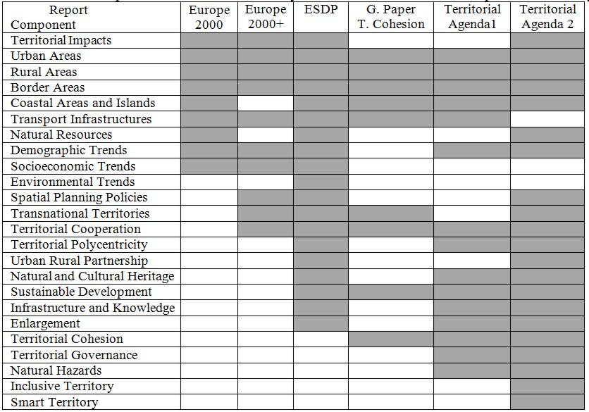

Source: (EC, 1991, 1994, 1999, 2007b, 2008b, 2011) - Author compilation

Again, the ESPON Programme strengthened the knowledge of many of these ‘territorial analytic components’, such as the: (i) territorial polycentricity; (ii) territorial impact assessment; (iii) urban-rural relationship; (iv) demographic trends; (v) transport networks; (vi) natural hazards and risks; (vii) natural and cultural heritage; (viii) urban system; (ix) territorial governance; (x) environmental trends; (xi) socioeconomic trends; (xii) rural areas; (xiii) maritime areas; (xiv) future territorial scenarios; (xv) land use pattern; (xvi) knowledge and innovation, and many others.

IV. AN INCREASING LEVEL OF THE TERRITORIAL DIMENSION IN THE EU COHESION POLICY INTERVENCTION STRATEGIES (1989-2020)?

**1. The EU Cohesion Policy and Territorial Development?**

As the name suggests, the EU Cohesion Policy, at its core, aims at reducing disparities in the EU territory. For the most part, the available literature identifies three different types of disparities: social, economic and territorial (see Molle, 2007; Potluka, 2010; Leonardi, 2005). This rationale is, however, in our view, very much redundant, as the territorial dimension of development inevitably encompasses social and economic aspects. Yet, Leonardi (2005: 6) is clearer on the role of ‘territory’ as a fundamental aspect of the EU Cohesion Policy, as it: (i) helps to identify the place where the policy is implemented; (ii) proposes a territorial level for its implementation; and (iii) involves local and regional institutions. Alternatively, Molle (2007: 83) has a more econometric perspective of the meaning of territorial dimension, by proposing three major aspects of territorial disparities: (i) access to markets; (ii) access to know-how and to innovation; and (iii) lack of access to certain services.

As expected, since the landmark reform of the EU Cohesion Policy, in 1988 - which introduced the multi-annual programming phases, the strategic orientation of the investments, and the principles of concentration, additionality and partnership -, this Policy suffered from many substantial reforms and changes, most of them as a result of the socioeconomic context by the time each programming period was being prepared. Moreover, the presence of a ‘territorial dimension’ in each programming period intervention strategy depended on intervention rationale present in the mainstream political and/or strategical EU guidelines (Treaties and Strategic Development Agendas such as the Agenda 2000 and the Europe 2020).

Yet, to provide a firm foundation to our analysis, we propose an analytical framework which relates the degree of the ‘territorial dimension’ of a given policy (in this case the EU Cohesion Policy) to the main pillars, dimensions and scales of the concept of territorial development. More precisely, we suggest three different levels of policy territorialisation, which can be considered high if the analysed Policy can clearly extend its action into the three pillars of territorial development, encompass the five dimensions of territorial development, and cover one or more territorial scales of analysis (Fig. 1).

Under this context, and when it comes to the EU Cohesion Policy, the first programming period (1989-1993) was greatly influenced by the accession of the Iberian Countries (Portugal and Spain - 1986), which significantly widened the existing territorial disparities in all territorial development dimensions. In addition, the intervention strategies were greatly influenced by the signing of the Single European Act, in 1986, which had as a major goal to establish a single market by 1992. Alongside, there was a political will to promote socioeconomic cohesion to face the potential risks of the implementation of the single market, namely in aggravating territorial imbalances. As such, the less developed (or Objective 1) regions received the bulk of the financial support, in order to improve their levels of economic competitiveness, social cohesion and environmental sustainability.

The following programming period (1994-1999) initiated the ‘seven year programming phases’, and was mainly influenced by the signing of the Maastricht Treaty, in 1992. Here, the novelty was the establishment of an additional financial instrument (the Cohesion Fund), and an EU institution concerned with the regional dimension of policies (the Committee of the Regions). Moreover, the accession of three additional Member-States (Sweden, Finland and Austria) not only enlarged the EU territory, but also saw the extension of EU peripheral and less populated territories, which led to the inclusion of a specific objective of the EU Cohesion Policy, to deal with such type of regions in Sweden and Finland. What is more, the political movement towards and economic and monetary union was underway. Nevertheless, the ‘objective structure’ of the EU Cohesion Policy was basically left unchanged, as the less developed regions continued to be favoured by the available funds, in order to promote their development and structural adjustments.

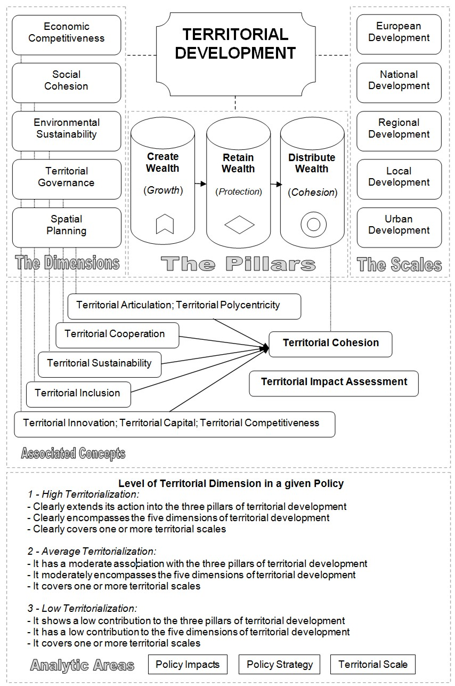

Fig. 1 – The analytical model of the territorial dimension

*Fig 1 - O modelo analítico da dimensão territorial*

Undoubtedly, the third programming period (2000-2006) of the EU Cohesion Policy continued to put emphasis on the goal of promoting economic and social cohesion in the EU territory. Yet, by this time, it was significantly influenced by the release of the Agenda 2000, in July 1997, and the accession of ten new Eastern European Member-States, by 2004. Essentially, the major consequences for this policy were the reduction of the number of main objectives to three, and the increasing awareness of the need to improve the policy monitoring and evaluation processes. Inevitably, the less developed regions continued to receive the lion’s-part of the financial aid (72%), in line with the continuous goal of reinforcing the socioeconomic cohesion, and of reducing the gaps towards the most developed EU regions.

On its term, the fourth programming period (2007-2013) saw a continuation of this tendency to concentrate the bulk of the financial resources to these less developed EU areas. At the same time, some major changes in this Policy implementation took place, like the extension of the financial support to all EU regions, and a shift of the Policy priorities, from the traditional mainstream cohesion goal to the focus on supporting growth, jobs and innovation, following the guidelines expressed in the Lisbon agenda. Conversely, the European Territorial Cooperation was side-lined as the third EU Cohesion main Objective, after the Convergence, and the Regional Competitiveness and Employment ones. Alongside, the expansion of the EU territory continued with two new Member-States (Romania and Bulgaria), which significantly increased the number of less-development areas in the EU.

Finally, the present programming period (2014-2020) was aligned with the Europe 2020 Strategy, in order to make it a tool which could channel regional resources to job creation, and smart, sustainable, and inclusive growth (EC, 2012). This shift towards growth and the renaming of the Structural Funds to ‘European Structural & Investment Funds’, can provoke a type of draining effect on the initial cohesion and development focus of the EU Cohesion Policy. As a consequence, this increasing emphasis on the economic dimension of development might lead to the gradual reduction of a territorial and more holistic vision to the EU territorial development, which has characterized the EU Cohesion Policy since it was established.

Another complementary overlook at the importance of the ‘territorial dimension’ of the EU Cohesion Policy can be provided by the reading of the six published Cohesion Reports (Table II). Crucially, a general overview of this table provides us a marked contrast with the baseline rational of this Policy, which has been markedly shifting from the Cohesion to a Growth perspective, since 2007. Curiously, the use of the term ‘Territorial Dimension’ in the existing Cohesion Reports has increased over time, and is especially strong in the last two. Here, the Fifth Cohesion Report identifies several policies with marked territorial dimension, and others with partial territorial dimension. It also recognizes that there is a need to improve the territorial dimension from the impact assessment procedures of policies (EC, 2010). On its term, the Sixth Cohesion Report (EC, 2014) highlights the importance of the need to make use of the territorial dimension, with a sense that the effects of policy measures in several areas of intervention vary significantly across regions.

Table II - The presence of the notion of ‘Territorial Dimension’ in the Cohesion Reports

*Quadro II - A presença da noção de ‘dimensão territorial’ nos relatórios de coesão*

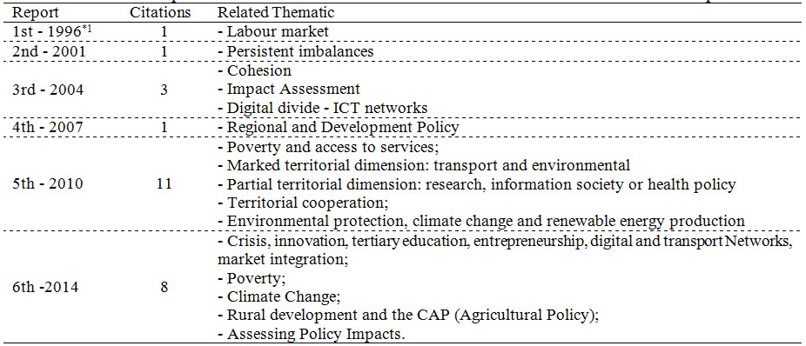

*1 - Used the term spatial dimension instead;

Source: (EC, 1996, 2001, 2004, 2007, 2010, 2014) - Author compilation

Simply put, if we apply the proposed model to assess the general level of territorialisation of the EU Cohesion Policy (1989-2020), we can assume that it has had, along its live cycle, a high territorialisation degree, based on the following generic conclusions:

* It is clear that the interventions financed by means of this Policy touched all pillars of territorial development, as it not only provided solid ground for wealth generation (modernization and building of new accessibilities, socioeconomic, and environmental related infrastructures, and support to the human capital valorisation), but was also pivotal in retaining and distributing wealth by supporting job creation. One can, obviously, question the degree of the long-term influence on the last pillar, as many created jobs were temporary and hardly well-paid;
* It is more than clear that this Policy financed projects which can be associated with all the dimensions of territorial development, despite the fact that they were more concentrated in providing support to business development, human capital, infrastructure, research and innovation, and environment protection. Even so, territorial cooperation and governance processes were also improved with a share of the EU Cohesion Policy investments, as well as spatial planning related components, such as the improvement of territorial connectivity and articulation. As Faludi (2010: 183) puts it, sound spatial planning is vital for this Policy to take into account the most adequate locations for its interventions and the related opportunities and constraints.
* The positive role of the EU Cohesion Policy is also evident and relevant in covering and impacting several territorial scales, from the urban to the European levels. In this particular analytic component, the attention given by this policy to the regional level was particularly strong, mainly through the regional Operational Programmes (OP). But here, the local level was also widely supported by specific initiatives as the Leader Community Initiative, for instance. Moreover, several large scale infrastructural programmes had a clear national perspective, and sometimes even a European dimension (transnational transport, energy, and cooperation networks).

**2. The EU Cohesion Policy and rise of the local and regional levels in the EU.**

As mentioned in the previous topic, the EU Cohesion Policy had a crucial role in supporting regional development processes in the EU, namely by financing EU regional Operational Programmes. It also goes without saying that a large part of the financial aid given to the objective of territorial cooperation (former INTERREG), in the three strands (cross-border, transnational and interregional cooperation), had not only a key role in reducing the barriers posed by the presence of borders (see Author, 2011), but also provided a stable arena for the emerging of euro-regional and macro-regional entities all over Europe (see Author 2013b; Perkmann, 2003; Perrin, 2010), and more recently, provided a stable ground for the establishment of European Groupings of Territorial Cooperation (EGTC) (De Sousa, 2013; CR, 2014). As can be seen in Figure 2, the scale of the territorial cooperation process across the EU today is enormous (Dühr et al., 2010), and has a multi-layered spectrum.

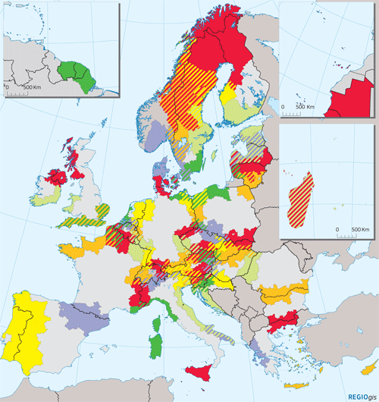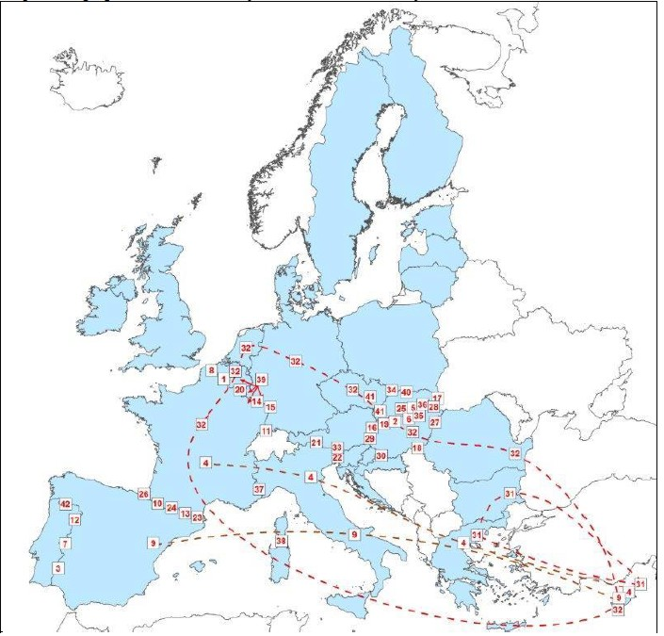

A

B

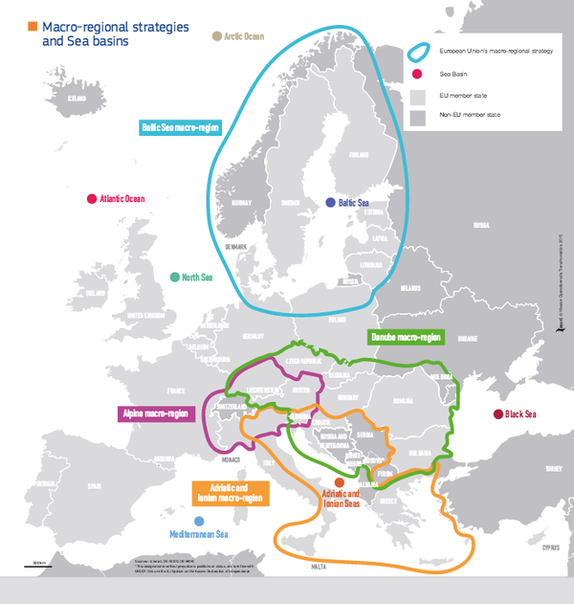

C

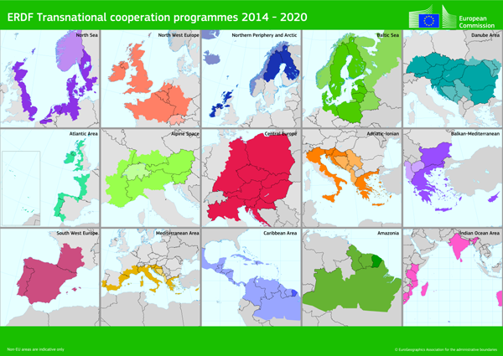

D

(A) / EGTCs - 2014, (B) / Macro-regional Strategies - 2015 (C), and Transnational Cooperation Programmes - 2014-2020 (D) in Europe - Source (EC, 2015; CR, 2014 + European Commission)

Fig. 2 - Cross-Border Cooperation Programmes - 2014-2020

*Fig.2 - Programas de Cooperação Transfronteiriça - 2014-2010*

More generally, when it comes to the European Integration process, available literature holds that there is a certain ambiguity in its effect on the regional power, since sometimes it has been affecting positively empowerment processes in certain EU regions, while in other cases it has supported disempowerment processes (see Bourne, 2003). In this line of reasoning, and according to Bache and Jones (2000), taking the UK and Spanish case, the EU Cohesion Policy influence on regional empowerment depends on three main things. In the first place, is the Policy Implementation Framework. Here, the introduction of the partnership principle changed the opportunity to structure the regional participation within the EU Cohesion Policy. In second place is the regional capacity to take advantage of available support from Policies. Understandably, this capacity varies from region to region (see Rodríguez-Pose and Garcilazo, 2015). Finally, in third place is the type of territorial structure of the state, and in particular the relation between the central state and the different peripheries. Again here, the EU territory encompasses a myriad of completely different situation cases (see Arribas 2012; ESPON 2.3.2, 2006).

In the eyes of some, however, the architecture of the EU Cohesion Policy, which favours the implementation of a multilevel type of governance, leads to a gaining influence of sub-national stakeholders (Faludi, 2010: 173). Likewise, the direct and indirect effects of this Policy in strengthening the territorial cooperation process, and in promoting sound territorial governance processes (Luukkonen and Moilanen, 2012), can act as a tool to promote local and regional empowerment, despite the fact that the EU is a “highly heterogeneous space in terms of institutional and governance issues, and in terms of both the different national and regional modes”. Conversely, Zaucha *et al.* (2014: 249) argue that “almost 20 years of intergovernmental cooperation on territorial development among EU Member States has barely reinforced multiannual programming in relation to EU development (cohesion) policy”.

**3. Territorial Impact Assessment, Place-Based Approach, and Territorial Cooperation: the visible ide of the moon in giving rise to the territorial dimension in the EU Cohesion Policy?**

We do not necessarily disagree with the argument that the “territorial dimension of EU Cohesion Policy has not yet been fully taken into account” (Zaucha *et al.*, 2014: 249). Nevertheless, as seen previously in this article, there can be no doubt about the importance of this Policy in several dimensions, scales, and pillars of the Territorial Development concept. We also believe that the territorialisation of policies in the EU is far from being consolidated. To improve this scenario, the cited authors launch the concept of ‘Territorial Keys’, with a view to translate the Territorial Agenda into a set of policy tasks. In sum, such Keys are identified in order to guide policy-makers, to highlight the role of the territorial structures for growth, to ensure a place-based policy programming, and to make policy interventions more efficient (Zaucha *et al.*, 2014):

* Accessibility: transport accessibility, accessibility to energy networks and e-connectivity;
* Services of General Economic Interest: education, healthcare, social care, communications policies, municipal services management;
* Territorial Capacities/Endowments/Assets.
* City Networks: urban policy, education, R&D, industrial, regional, national development;
* Functional Regions.

Put together, these territorial keys could indeed be quite relevant in increasing the territorialisation level of policies. Regarding this concept, Figueiredo (2010: 11) relates it to the conception and implementation of programmes/projects with relevant territorial impacts, whose intervention priorities are defined in strategic frameworks for a specific territory, and which have a formal or informal participation of institutions and stakeholders associated with a given territory. The same author adds to this discussion by arguing that the territorial attractiveness is built around three sustainability vectors: economy, society and environment. Once again, we come across with this perennial political-correct dimensional triangle associated with the notion of territory, which we fully disagree with.

Going back to the direct and indirect contribution of the EU Cohesion Policy to the ‘reinforcement’ of the territorial dimension of the associated projects and programmes, the reading of Table III facilitates this analysis, by putting forward the ‘major vehicles’ which bring the territorial dimension of this Policy into play. To start with, the implementation of this Policy requires systematic monitoring and evaluation procedures. Here, as previously explained, the use of Territorial Impact Assessment (TIA) procedures has been gaining ground on a steady but persistent manner (Author, 2014c). Associated with this fact are the studies and reports produced under the auspices of the ESPON Programme, which extend their territorial analysis to several other ‘territorial related themes’. Likewise, the EU institutions (mostly the European Commission and the Committee of the Regions) have been producing studies with a strong geographical perspective, including the Cohesion Reports, which analyse many domains of the EU Cohesion Policy, at the national and regional levels.

Moreover, several sectoral policies financed with EU Cohesion Policy funds have a clear territorial dimension. In this regard, we highlight the transport, the environmental, the urban, and the social related policies. Again, we stress the role of the European Territorial Cooperation programmes in promoting the territorial dimension of the EU Cohesion Policy, not only by reinforcing the role of the EU regional level, but also by establishing concrete forms of multi-level governance. In this respect, Stead (2004) recognizes that the emerging notion of territorial governance onto the European policy agenda is often related with the notion of multi-level governance. Further on, he proposes the use of territorial governance when certain elements are present: (i) managing territorial dynamics, (ii) assessing territorial impacts and (iii) delineating policy boundaries. Under this perspective, the EU Cohesion Policy places a strong emphasis on the first two elements, directly or indirectly.

Table III - Areas where the contribution of the EU Cohesion Policy can reinforce the territorial dimension

*Quadro III - Áreas onde a contribuição da Política de Coesão pode reforçar a dimensão territorial*

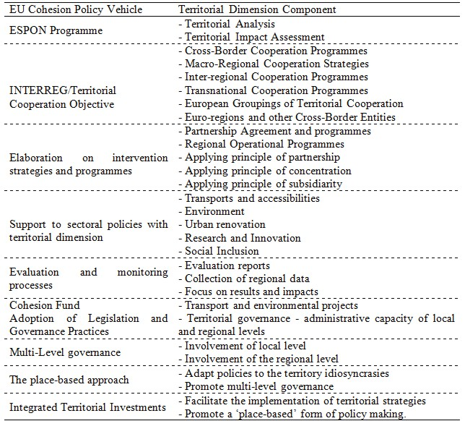

Source: Author elaboration

As seen along this text, the EU Cohesion Policy has an intrinsic association with several territorial related elements. Amongst them we highlight three. The first is related with the increasing awareness from the EU institutions on the need to make use of more complete, holistic and territorial policy impact assessment procedures, which culminated with the publication, in 2012, of a Practical Guidance for Policymakers and Practitioners based on contributions from ESPON projects and the European Commission, on the use of Territorial Impact Assessment (TIA) in Policies and EU Directives (ESPON, 2012). However, the existing EU Impact Assessment Guidelines lack this territorial vision, by limiting the policy impact assessment analysis on the likely economic, social and environmental impacts of Policies (see EC, 2009). Even so, and despite the necessary developments in making some used TIA tools by the EU institutions more relevant in their results, the simple fact that they are being implemented, namely for assessing EU Directives, is a clear sign of the recognition of the territorial dimension as a key aspect of policy monitoring and evaluation procedures within the EU.

The second major territorial element which we regard as potentially relevant in this analysis is the place-base narrative, associated with the implementation of the EU Cohesion Policy, which has its roots in the ‘Barca Report’ (Barca, 2009). In simple terms, this place-based vision reformulates the key objective of the EU Cohesion Policy into tapping the under-utilized potential of all EU places (Mendez, 2013). Understandably, this narrative has a clear territorial perspective, and recognizes that econometric studies do not offer any conclusive general answers on policy impact. At the same time, this approach intends to make use of the EU Cohesion Policy potential to reinforce the multi-level governance processes, to explore EU-wide networks for cooperation, and to disseminate operational experiences (Barca, 2009).

Finally, the territorial cooperation process in the EU, which can be defined as a “process of collaboration between different territories or spatial locations” (Author, 2015), is probably the most relevant territorial related element associated with the implementation of the EU Cohesion Policy. This importance can take several prisms. For one, this process involves all the EU territory, through the transnational cooperation process (former INTERREG strand B). But even the most financed strand of the European cooperation processes by the EU Cohesion Policy (the cross-border cooperation strand) covers 60% of the EU territory (NUTS 3), which encompasses more that 40% of the EU territory (Author, 2010). Add to that, the existing macro-regional strategies (Baltic-Sea Region, Danube, Adriatic and Ionian, and the Alpine-Macro Regions) add a crucial coordinated response to environmental problems, and to overcome obstacles holding up the development of certain EU territories (EC, 2013).

**4. Does Territorial Cohesion still matter for the EU Cohesion Policy?**

Despite the recent trends of the EU Cohesion Policy to evolve into a type of ‘investment’ Policy, in contrast with its own designation, as the associated Funds (European Regional Development Fund, European Social Fund, Cohesion Fund, European Agricultural Fund for Rural Development, and European Maritime & Fisheries Fund) have started to be officially known as ‘European Structural & Investment Funds’ since 2014, this does not erase all its positive contributions to promote cohesion processes in the EU territory. Notwithstanding, does this signify that the EU Cohesion Policy is less and less about ‘cohesion’ and more and more about ‘investment’ at its core? Here, the reading of the most recent EU regulation laying down common provisions on the European Cohesion and Investment Funds continue to base its intervention rationale on the Article 174 of the Treaty on the Functioning of the European Union, which highlights the need to strengthen the economic, social and territorial cohesion of the EU territory (EC, 2013b).

In this context, there is no reason to believe that that EU Cohesion Policy is no longer a crucial tool to achieve the goal of territorial cohesion expressed in the Lisbon Treaty. However, we can dispute the idea that this goal is a mere utopia in a globalized word, which hardly favours a more balanced and harmonious territorial development, towards the goal of territorial cohesion. In this regard, one has to start by defining what is the exact meaning of ‘territorial cohesion’ which, as Clifton *et al*. (2015) conclude, is a complex and evolving concept. In this regard we have been proposing, for a long time (see Author, 2012), the following definition: the process of promoting a more cohesive and balanced territory, by: (i) supporting the reduction of socioeconomic territorial imbalances; (ii) promoting environmental sustainability; (iii) reinforcing and improving the territorial cooperation/governance processes; and (iv) reinforcing and establishing a more polycentric urban system.

Under this view, and after creating a methodology which measures the change of the territorial cohesion over a period of time, in some European nations (see Author, 2012b; Author, 2014d), both at the national and regional levels, we can conclude that, despite the pivotal positive impacts of the EU Cohesion Policy in most of the dimensions of the territorial cohesion concept (mainly in the promotion of socioeconomic cohesion and environmental sustainability), this was not sufficient to counteract the perennial territorial trends which favour the development of the main urban agglomeration areas in the EU territory, vis-à-vis the peripheral and less populated areas. As such, the concretization of the goal of territorial cohesion in the EU requires not only additional funding to support the development of lagging regions, but also a clear territorial strategy which can beneficiate, for instance medium-towns, as EU development anchors, towards a more balanced and polycentric territory.

V. CONCLUSIONS

The simple fact that the EU Cohesion Policy aims at achieving a more cohesive EU territory connects it with a clear ‘territorial dimension’. To state otherwise is, in our view, to hinge on a simplistic and ungrounded perspective, which ignores the important role of this mainstream EU Policy in reinforcing the pillars and main dimensions of territorial development, in all the administrative levels of the EU. Alongside, this Policy has had, throughout its almost 30 years of implementation, a crucial role in providing financial support to sectoral policies with a strong territorial dimension (transports, environment, urban renovation, research and innovation, and social policies), and in supporting territorial cooperation and multi-level governance processes. Furthermore, the elaboration of national and regional intervention strategies, which are necessary to have access to the available EU funds, together with the obligation to establish monitoring and evaluation practices, has led to a better understanding and wider knowledge of the territorial capital, and development needs at all territorial levels.

Moreover, the multiplier effects of the EU Cohesion Policy in ‘touching’ several elements of the territorial dimension are extensive to the academic community, and to the myriad of stakeholders involved in the operationalization of the EU Cohesion Policy. More precisely, the academic community has been involved in providing sound territorial knowledge on the effects and impacts of the investments associated with this policy, namely with the elaboration of reports and studies under the auspices of the ESPON Programme, and the programme’s evaluation reports. Furthermore, the release of the mentioned Territorial Agendas, the Green Paper on Territorial Cohesion, the ESDP, and the Scenarios for Integrated Territorial Investments (EC, 2015b), are proof of the awareness of the need to provide a more holistic, complete, integrated and territorial perspective, when implementing EU Cohesion Policy related programmes.

All in all, and by making use of a methodology which takes into account the presence of several territorial related elements in a given policy, such as the ones previously mentioned, we can conclude that there is a strong case to argue that the EU Cohesion Policy has a high level of territorialization. No less fundamental to this analysis is the critical role that this policy has had in supporting the development of sub-national administrative scales, and in particular the regional level, at least in less development EU countries. In this regard, the claims which require the need for a more place-based approach to this policy also unveil its substantial territorial dimension. Additionally, the increasing importance of the support provided through the financial support given to the territorial cooperation goal of this Policy unfolds a key territorial dimension, as the main strand of this goal (cross-border cooperation), financially speaking, covers more than 60% of the EU territory. Also, the rise of the macro-regional strategies (four in late 2015), alongside with the constant establishment of the European Groupings of Territorial Cooperation (55 in late 2015), provides further impetus to the reinforcement of territorial cooperation networks within the EU.

Finally, our own detailed analysis on the main territorial impacts of the EU Cohesion Policy in several EU Member-States and regions, has revealed the pivotal role of this Policy in supporting several pillars of the territorial cohesion concept, and mainly in improving social, economic, and environmental related components in the intervention territories, with particular emphasis in improving the infra-structural and the human capital domains. However, and despite the multiple positive direct and indirect impacts provoked by the programmes financed under the auspices of this Policy, the goal of achieving a more cohesive and balanced territory at the national level, has not been attained. On the contrary, despite a wider canalization of financial support to the less developed regions, the larger EU metropolitan areas continue to gain in their overall relative position, in terms of their socioeconomic and demographic attractiveness. What is more, the ESDP goal of establishing a more polycentric urban system in the EU Member-States was not achieved in the territories which we have studied with greater detail (Portugal, Spain, and Sweden).

To conclude, and following from the above, we could see that, despite the constant reforms and reshapes, which have been attempting to push the EU Cohesion Policy further away from its initial goals as a cohesive policy, into a more neoliberal and Anglo-Saxon investment policy, it still maintains a resilient relation with many elements associated with the territorial dimension of policies. Against this background, we can argue that, in order to reinforce this territorial dimension, this Policy needs further action from both the academic community and the involved political actors. The formers have on their hands the continuation of the efforts to highlight the need for better understanding the territorial impacts of this policy, and to design better spatial development strategies, with an integrated territorial approach, and which launch concrete measures to achieve a more balanced, harmonious and polycentric urban system within the EU territory.

On their part, the latter (policy-makers) should be provided with better territorial analyses, and evaluation reports of the main territorial impacts of the EU Cohesion Policy, in order to make more rational and intelligent decisions on the necessary thematic concentration of the available investments. Also, the EU policy makers should be aware that relevant territorial impact assessment procedures require more than a simple press-of-a-button gesture, and that the analysed territorial dimensions of policies extend the economy-society-environment triangle. Consequently, the investment in improving available statistical data collection is of crucial importance to better understand the policy causalities in the all dimensions of territorial development.

In the end, the presented analysis intends to provoke an accelerated debate on the future trends of the EU Cohesion Policy, and to highlight the need to take into account and reinforce its territorial dimension, and the consequent need to implement the proposals expressed in the Territorial Agenda, as a means to complement the ‘territorialess EU 2020 strategy’. Moreover, we expect that the academic and political discussion on the ‘territorial dimension’ of the EU Cohesion Policy leads to a wider awareness on the importance of the geographical analysis of Polices, in order to better understand their territorial impacts in all the dimensions of territorial development.

References:

Arribas, G.V. (Coord.) (2012) *Division of Powers between the European Union, the Member States, and the Regional and Local Authorities*, European Institute of Public Administration (EIPA), Committee of the Regions, Brussels.

Bache, I; Jones, R. (2000*) Has EU regional policy empowered the regions?* *A study of Spain and the United Kingdom*, Regional & Federal Studies, 10(3): 1-20.

Barca, F. (2009) *An agenda for a reformed cohesion policy: a place-based approach to meeting European Union challenges and expectations*, Independent Report prepared at the request of Danuta Hübner, Commissioner for Regional Policy, DG Regional Policy, Brussels.

Bourne, A K. (2003) *The Impact of European Integration on Regional Power*, Journal of Common Market Studies, .41, (4): 597–620.

Clifton, J.; Díaz-Fuentes, D.; Fernández-Gutiérrez, M. (2015) *Public Infrastructure Services in the European Union: Challenges for Territorial Cohesion*, Regional Studies, DOI: 10.1080/00343404.2015.1044958

CR (2014*) EGTC monitoring report 2014. Implementing the Strategy Europe 2020*, Committee of the Regions /METIS, Brussels.

De Sousa, L. (2013) *Understanding European Cross-border Cooperation: A Framework for Analysis*, Journal of European Integration, 35(6):.669–687.

Delaney, D. (2009) *Territory and Territoriality*, International Encyclopedia of Human Geography, Elsavier, Conventry, Vol. 11, 196-208.

Dühr, S.; Colomb, C.; Vincent, N (2010) *European Spatial Planning and Territorial Cooperation*, Routledge, London.

EC (1983) *European regional/spatial planning Charter. Torremolinos Charter*, European Conference of Ministers Responsible for Regional Planning, adopted on 20 May 1983 at Torremolinos (Spain), European Commission, Strasbourg.

EC (1991) *Europe 2000: outlook for the development of the community’s territory*, Commission of the European Communities, Directorate-General for Regional Policy, Luxemburg.

EC (1994) *Europe 2000+. Cooperation for European territorial development*, European Commission, Luxemburg.

EC (1996) *First report on economic and social cohesion*, European Commission, Luxembourg.

EC (1999) *European Spatial Development Perspective: Towards Balanced and Sustainable Development of the Territory of the EU*. Office for Official Publications of the European Communities, Luxembourg.

EC (2001) *Second Report on Economic and Social Cohesion*, European Commission, Luxembourg.

EC (2004) *A new partnership for cohesion – convergence, competitiveness, cooperation, Third report on economic and social cohesion*, European Commission, Luxemburg.

EC (2007) *Growing Regions, Growing Europe. Fourth report on economic and social cohesion*, European Commission, Brussels.

EC (2007b) *Territorial agenda of the European Union - Towards a More Competitive and Sustainable Europe of diverse regions*, final draft, Agreed on the occasion of the Informal Ministerial Meeting on Urban Development and Territorial Cohesion in Leipzig on 24 / 25 May 2007, European Commission, Brussels.

EC (2008) *EU Cohesion Policy 1988-2008: Investing in Europe’s Future*, Inforegio - Panorama nº26 - June 2008, European Commission, Luxembourg.

EC (2008b) *Green Paper on Territorial Cohesion - turning territorial diversity into strength*, European Commission, Brussels.

EC (2009) *Impact Assessment Guidelines*, 15 January 2009, European Commission, Brussels.

EC (2010) *Investing in Europe’s future: Fifth report on economic, social and territorial cohesion*, European Commission, November 2010, Brussels.

EC (2010b) *Lisbon Treaty*. Official Journal of the European Union C83, Volume 53, 30 March, Brussels.

EC (2010c) *EUROPE 2020 - a strategy for smart, sustainable and inclusive growth*, Communication from the commission, 3.3.2010, European Commission, Brussels.

EC (2011) *Territorial Agenda of the European Union 2020 Towards an Inclusive, Smart and Sustainable Europe of Diverse Regions*, agreed at the Informal Ministerial Meeting of Ministers responsible for Spatial Planning and Territorial Development on 19th May 2011, Gödöllő.

EC (2012) *Cohesion Policy 2014-2020. Investing in Europe’s regions*, Inforegio - Panorama nº40, European Commission, Luxembourg.

EC (2013) *Report from the Commission to the European Parliament*, the Council, The European Economic and Social Committee and the Committee of the Regions concerning the added value of macro-regional strategies, SWD(2013) 233 final, European Commission, Luxembourg.

EC (2013b) *Regualtion (EU) No 1303/2013 of the European Parliament and of the Council. 17 December 2013, Official Journal of the European Union*, 20.12.2013, L 347/320, European Commission, Luxembourg.

EC (2014) *Sixth Report on Economic, Social and Territorial Cohesion. Investment for jobs and growth: Promoting development and good governance in EU regions* and cities, European Commission, July 2014, Brussels.

EC (2015) *Territorial Cooperation. A Historical Perspective*, European Commission, Regional and Urban Policy, Luxembourg.

EC (2015b) *Scenarios for Integrated Territorial Investments*, October 2015, Directorate-General for Regional and Urban Policy, European Commission, Brussels.

Encarta (2009) *Microsoft Encarta Premium*, Microsoft Corporation, DVD-ROM, Redmond.

ESPON 2.3.2 (2006) *Governance of territorial and urban policies from EU to local level.* Final report (31st May 2006), ESPON, Luxembourg.

ESPON (2012) *Territorial Impact Assessment of Policies and EU Directives.* A practical guidance for policymakers and practitioners based on contributions from ESPON projects and the European Commission, ESPON, Luxembourg.

ESPON ATLAS (2013) *Territorial Dimensions of the Europe 2020 Strategy,* European Spatial Planning Observation Network, Luxembourg.

Faludi, A. (2006) *From European spatial development to territorial cohesion policy*, Regional Studies, 40(6): 667-678.

Faludi, A. (2010) *Cohesion, Coherence, Cooperation: European Spatial Planning Coming of Age?* Routledge, London.

Ferrão, J. (2010) *Ordenamento do território: 25 anos de aprendizagem*? in Europa Novas Fronteiras, Portugal – 25 anos de Integração Europeia, Princípia, 26/27: 77-84.

Figueiredo, A. F. (Coord) (2010) *A territorialização de políticas públicas em Portugal,* Ed: Instituto Financeiro para o Desenvolvimento Regional, IP, Lisboa, pp.195.

Goodwin, Mark (2013) *Regions, Territories and Relationality: Exploring the Regional Dimensions of Political Practice*, Regional Studies, 47(8): 1181-1190.

Haggett, P. (2001) *Geography. A global synthesis*, Prentice Hall, London.

Leonardi, R. (2005) *Cohesion Policy in the European Union - The Building of Europe*, Palgrave Macmillan, New York.

Luukkonen, J.; Moilanen, H. (2012) *Territoriality in the Strategies and Practices of the Territorial Cohesion Policy of the European Union: Territorial Challenges in Implementing “Soft Planning”*, European Planning StudiesVolume 20(3): 481-500.

Martin, J.; Rhys, J.; Michael E. (Eds.) (2004) *An introduction to political geography*. Space, place and politics, Routledge, London.

Molle, W. (2007) *European Cohesion Policy*, Routledge, London.

Moreno, L. (2002) *Desenvolvimento Local em Meio Rural. Caminhos e Caminhantes*. Dissertação de Doutoramento, Universidade de Lisboa, Faculdade de Letras, Lisboa.

Perkmann, M. (2003) *Cross-border regions in Europe - Significance and drivers of regional cross-border co-operation,* European Urban and Regional Studies, 10: 153–171.

Perrin, T. (2010) *Inter-territoriality as a new trend in cultural policy? The case of Euroregions*, Cultural Trends, 19(1-2): 125-139.

Potluka, O. (2010) *Impact of EU Cohesion Policy in Central Europe*, Leipziger Universitätsverlag, Leipzig.

Rodríguez-Pose, A.; Garcilazo, E. (2015) *Quality of Government and the Returns of Investment: Examining the Impact of Cohesion Expenditure in European Regions*, Regional Studies, 49:8, 1274-1290.

Sack, R. (1983) *Human Territoriality: A Theory*, Annals of the Association of American Geographers, 73(1): 55-74.

Stead, D. (2014) *The Rise of Territorial Governance in European Policy*, European Planning Studies, 22(7), 1368-1383.

Trigal, L.L. (Ed.) (2015) *Diccionario de Geografía Aplicada Y Prodesional*. Terminología de análisis, planificación y gestión del território, Universidad de León.

Zaucha, J.; Komornicki, T.; Böhme, K.; Świątek, D.; Żuber, P. (2014) *Territorial Keys for Bringing Closer the Territorial Agenda of the EU and Europe 2020*, European Planning Studies. 22(2): 246-267.

1. Conference: The EU Cohesion Policy in Portugal - Contributions to the Territorial Development - 28-01-2013 -