**TITLE: Combined hamartoma of the retina and RPE: clinical case**

**TÍTULO: Hamartoma combinado da retina e EPR: caso clínico**

**Introdução:** O hamartoma combinado da retina e epitélio pigmentado da retina (HCR-EPR) é uma malformação congénita rara constituída por uma mistura de tecido glial, vasos retinianos, retina e EPR com grau variável de distúrbios ao nível da interface vítreo-retiniana. Ocorre geralmente de forma isolada, embora alguns casos tenham associação sistémica, particularmente a Neurofibromatose dos tipos 1 e 2; **Métodos:** Relato de um caso clínico; **Resultados:** Um menino de 7 anos foi referenciado por estrabismo divergente e hipovisão do olho direito (OD). A acuidade visual era de 1/10 no OD e 10/10 no olho esquerdo e não melhorava com correção. O estudo do alinhamento ocular revelou uma exotropia do OD. A oftalmoscopia do OD revelou uma lesão discretamente elevada, acinzentada, com marcada tortuosidade vascular e quase totalmente recoberta por tecido fibroglial, com distorção macular e que se estendia para além dos limites do pólo posterior e incluía o disco ótico. A angiografia fluoresceínica, o OCT e a ecografia oftálmica corroboraram o diagnóstico de um HCR-EPR. O estudo sistémico, que incluiu ressonância magnética cerebral, foi normal. A lesão mantém-se inalterada após 1 ano de seguimento; **Conclusões:** Relatamos um caso raro de HCR-EPR, com diagnóstico relativamente tardio, atendendo ao atingimento foveal e às dimensões significativas da lesão. Embora o diagnóstico seja essencialmente clínico, o estudo com angiografia, OCT e ecografia oftálmica são fundamentais para confirmação diagnóstica e exclusão de patologia tumoral maligna da retina e coróide.

**Palavras-chave:** Hamartoma, Retina, Epitélio pigmentado da retina (EPR), Neoplasia ocular

**Introduction:** The combined hamartoma of the retina and retinal pigment epithelium (CHR-RPE) is a rare congenital malformation consisting of a mixture of glial tissue, retinal vessels, retina and RPE with varying degrees of disorder at the level of the vitreoretinal interface. It usually occurs isolated, although some cases may have systemic involvement, particularly neurofibromatosis type 1 and 2; **Methods:** Clinical case report; **Results:** A 7 years-old-boy was referenced to our department due to divergent strabismus and vision loss in right eye (OD). Visual acuity was 1/10 in OD and 10/10 in left eye (OS) and did not improve with correction. The study of ocular alignment revealed an exotropia in OD. Ophthalmoscopy of OD revealed a slightly elevated gray lesion, with marked vascular tortuosity, almost completely covered by fibroglial tissue with macular distortion and extending beyond the limits of the posterior pole and including the optic disc. Fluorescein angiography, OCT and ophthalmic ultrasound corroborated the diagnosis of a CHR-RPE. The systemic study, which included cerebral magnetic resonance image, was normal. The lesion is stable after 1 year of follow-up; **Conclusions:** We report a rare case of a CHR-RPE, with relatively late diagnosis, given the grade of foveal commitment and the dimensions of the lesion. Although the diagnosis is essentially clinical, study with angiography, OCT and ophthalmic ultrasound is essential to confirm it and rule out malignant tumors of the retina and choroid.

**Keywords:** Hamartoma, Retina, RetinalPigmentedEpithelium (RPE), Ocular tumor

**INTRODUCTION**

The combined hamartoma of the retina and retinal pigment epithelium (CHR-RPE) is a rare ocular tumor, described by Gass in 19734. It represents a congenital malformation consisting of a mixture of glial tissue, retinal vessels, retina and RPE with a variable degree of disturbance at the level of the vitreoretinal interface 5,11,13. The initial diagnosis is often unknown or inocorrect13. Because it can mimic neoplastic pathology of the retina or choroid, its early and correct diagnosis is crucial. We present a case of a CHR-RPE, remarkable for its size and whose diagnosis was based on morphological characteristics of the lesion and typical findings in ancillary diagnostic exams.

**CLINICAL CASE**

A 7 year-old boy was referred to our department due to a divergent strabismus and subnormal vision in his right eye (OD). His gestation and delivery were uneventful and he had no personal or familiar relevant antecedents.

The ophthalmological examination showed visual acuities of 1/10 in OD and 10/10 in the left eye (OS), which did not improve with correction. Ocular movements were preserved and an exotropia of variable magnitude was present in OD. Biomicroscopy was normal and the intraocular pressures were 13mmHg bilaterally. While the OS fundocopy was normal, in the OD revealed a slightly elevated lesion with approximately 12x11mm, centered on the macula and extending to the mid-periphery, including the optic disk, with a blue-gray hue and almost completely covered by fibroglial tissue. The central vessels were tortuous and the peripherals were straight. The macula had a fibrotic pucker with nasal dragging of approximately 700μm and macular edema. The limits of the lesion were high, however no apparent tractional detachment was present in the transition to the surrounding retina (Fig. 1).

**Figure 1** – Fundus photography of the OD showing a showing a tractional retinal mass with marked gliosis and vascular tortuosity that extends beyond the boundaries of the posterior pole.

The lesion was studied with fluorescein angiography (FA), optical coherence tomography (OCT) and ophthalmic ultrasound (US), whose results revealed changes in the OD. FA showed initial blocking of the choroidal fluorescence, vascular tortuosity, macular diffusion in intermediate/ late stages, late staining and also moderate peripheral ischemia (Fig. 2A and 2B).

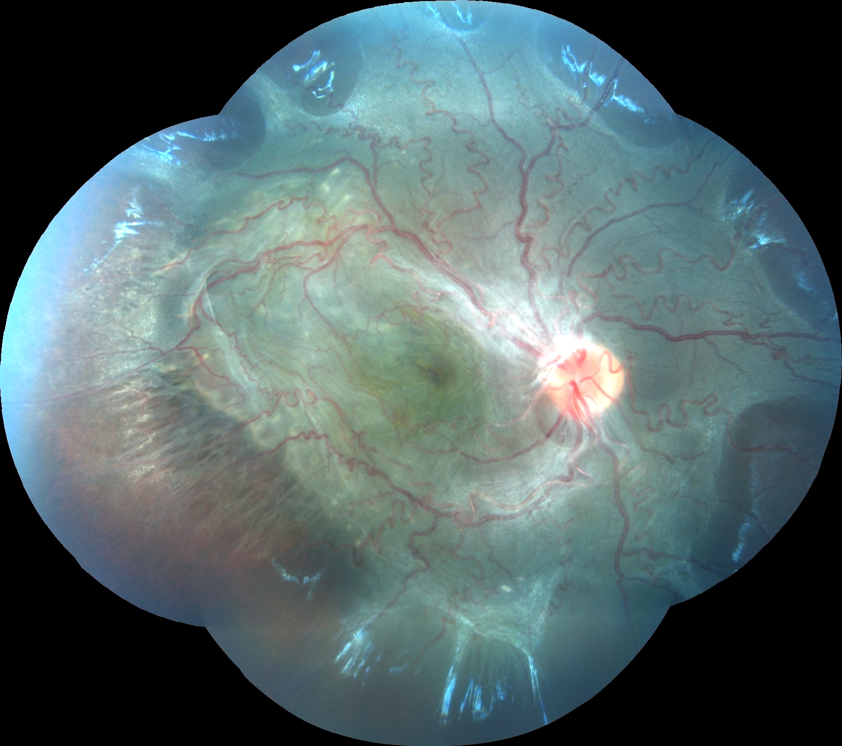The OCT (Copernicus, SOCT) revealed an epiretinal membrane (ERM) with macular traction conditioning folds and retinal striae, hiperreflectivity of the inner retina with posterior shadowing effect, important cytoarchitectural distortion, macular thickening of 605μm centrally and more than 1000μm next to the arcades and, also, atrophy/irregularity of both RPE and ellipsoid line (Fig. 2C).

Ophthalmic US revealed, in A-mode, a lesion with a hyperreflective retinal peak separated from the sclero-choroidal peak by a hypoechoic space; and, in B-mode, revealed a lesion confined to the retina, with a uniform elevation and a thicker and brighter inner surface (Fig. 2D).

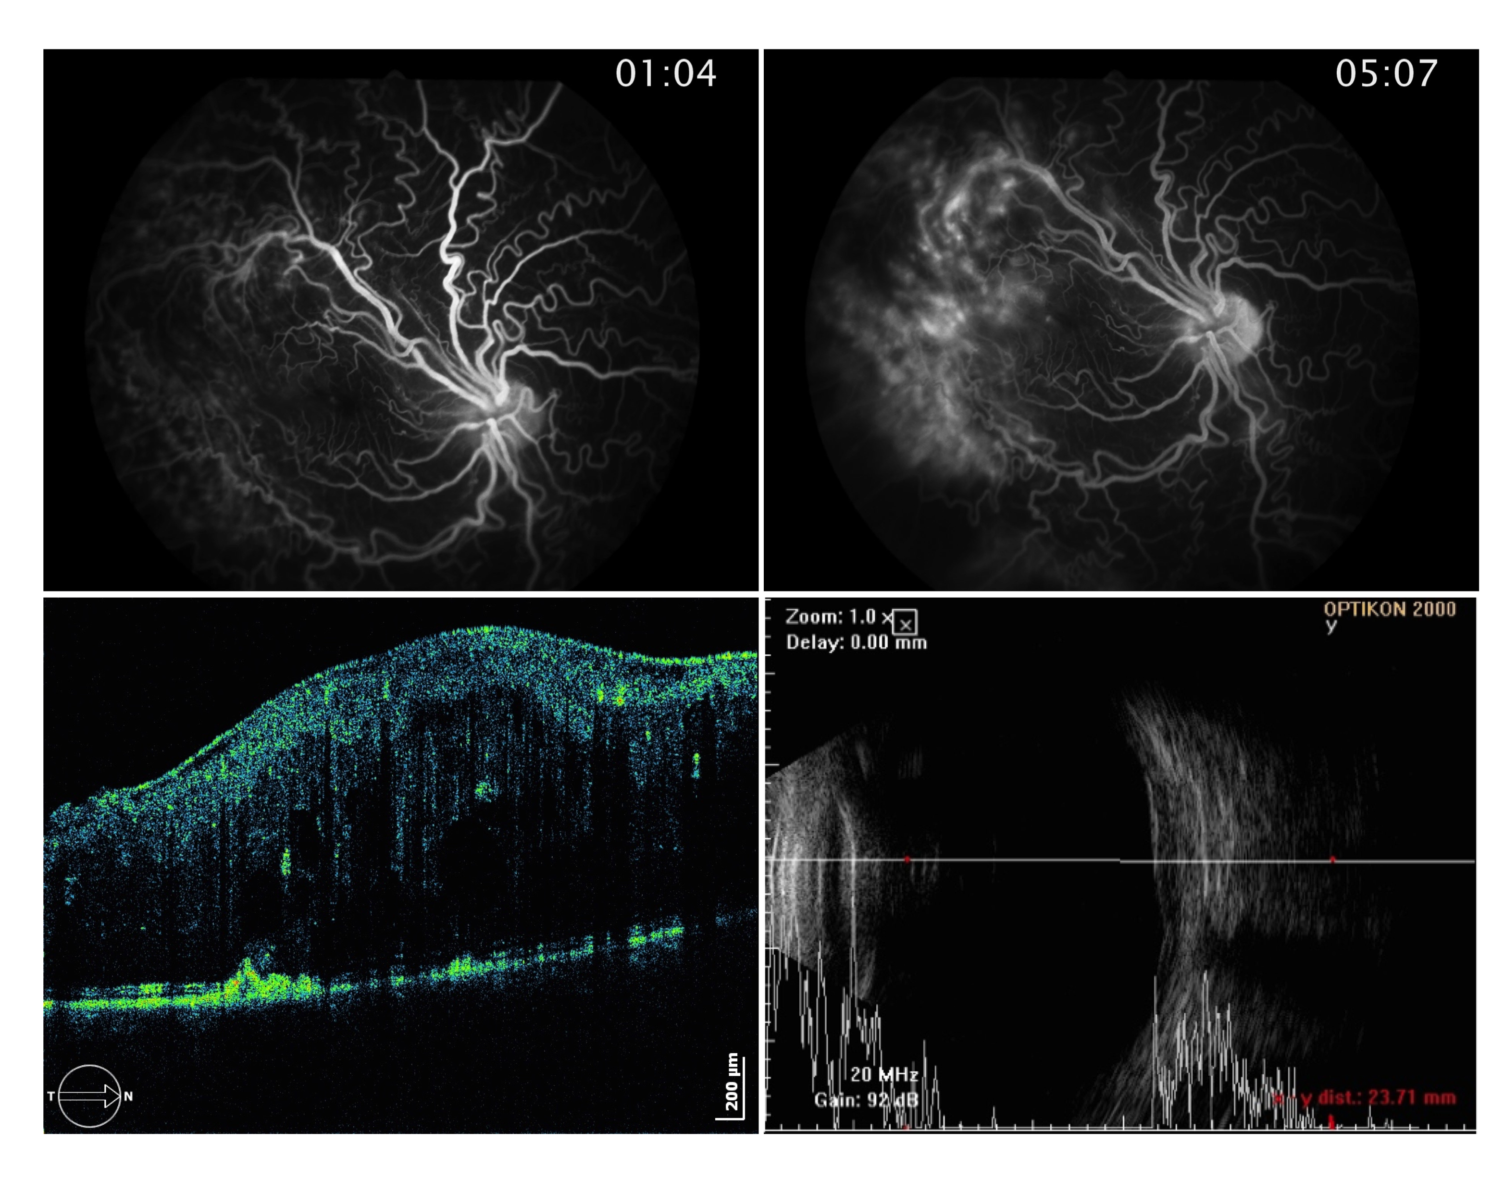

**Figure 2** – Ancillary diagnostic exams of the OD: A and B- Fluorescein angiography; B- OCT (Copernicus, SOCT); D- Ophthalmic ultrasound mode A+B.

Based on the described findings the diagnosis of a CHR-RPE was established in the OD. The study was further completed with a brain magnetic resonance imaging (MRI) that was normal except for a hypoplastic A1 segment of the right middle cerebral artery, with the A2 segment to be filled through the anterior communicating artery.

One year later, the injury and the visual acuity remains stable, being the child followed every 6 months in retina consultation.

**DISCUSSION**

The CHR-RPE represents a tractional mass, most frequently centered on the optic disc and with concomitant or isolated macular commitment in about half of the cases. 5,11,13.

In the study by Shields et al., with 77 cases, the average age of diagnosis was 9.5 months in cases with macular commitment (maximum of 44 months) and 14.5 months in purely extramacular cases13. The average diameters of the lesions in this study were, respectively, 6.6 and 8.5 mm13. This case is therefore a bit unusual for its late diagnosis, at 7 years of age, in view of its size and macular involvement.

Macular involvment determines the visual prognosis, being the predominant symptoms the same of this case, including decreased visual acuity and/or strabismus in 78% of cases13.

Its diagnosis is often unknown or incorrect, in about 75% of cases, being the most common misdiagnosis, in descending order of frequency, the melanoma and nevi of the choroid, retinoblastoma, retinal hemangioma, astrocytoma and toxocariasis13. Because it mimics retinal and choroidal oncologic pathology, its histopathological analysis was possible based on the enucleation of some of the first reported cases 2,7,14,15. The most common findings were: thickening of the retina and optic nerve, superficial retinal gliosis, dysplastic glial vascular tissue, reduplication of the RPE layer and, in some cases, invasion of the inner retina by strings and RPE bands2,7,14,15.

The fundus features of this CHR-RPE, marked by a disturbance at the level of the vitreoretinal interface, can be considered typical. This is characterized by the presence of thick ERM with macular dragging, which is present every time the macula is affected and in about half of extramacular cases11,13. Retinal vessels are dilated and tortuous in the most central areas of contraction of the lesion and stretched on the peripheral anchorage zones,5,11,13. Although the colour of this lesion, in grayscale, is the most common, it can also be more green, yellow, brown or orange and also present variable pigmentation11,13. It is believed that the pigmentation, which in this case is mild, rather than being a part of hamartous process itself, represents a reactive hyperplasia to retinal traction17.

Although the fundoscopy of this case is typical, the definitive diagnosis was only possible with the ancillary diagnostic tests performed.

FA shows vascular tortuosity. In complicated cases, there may be impregnation, delayed diffusion, ischemia and eventually neovascularization17.

OCT usually shows a thick and irregular ERM with a variable degree of traction and an outer hyperreflective surface with a shadow posterior effect1,3,12. Retinal cytoarchitectural disorganization, increased thickness and cystoid macular edema are not uncommon 3,12,17 as well as loss of RPE and ellipsoid line integrity1,3,12.

A-mode ophthalmic ultrasound typically shows an acoustically silent space in the tumour area, separating the retinal and the slero-choroidal peaks and, in B-mode, a thick and edematous retina6. Although there may exist adjacent vitreous changes, extension to the choroid or sclera never occurs6.

Although Gass4 in its initial description of this disease, with 7 cases, established the absence of tractional detachment, bleeding and exudation as diagnostic criteria, these complications can occur5,11,13. Rare cases with associated choroidal neovascularization and macular holes were reported13. Although the typical lesion is stable, the continuous loss of vision is common in the context of macular complications in cases of macular edema, tractional detachment and macular dragging.5,13.

The CHR-EPR is typically, like this case, an isolate finding4,13. Since some cases have associated systemic diseases, most frequently Neurofibromatosis type 2, but also type 1, the systemic study with brain imaging should be carried out.13. In this case, the brain magnetic resonance imaging was negative for brain hamartomas and gliomas. The hypoplastic A1 segment of the anterior cerebral artery is, in our view, an incidental finding, found in 10% of all post-mortem autopsies and in 3% of the studies with magnetic resonance angiography8.

Rare bilateral cases have been described in the context of systemic disease 10,18.

Apart from the treatment of amblyopia, surgical treatment of the CHR-RPE is not consensual. There are not much more than two dozen published cases of vitrectomy with ERM peeling, with functional success rates ranging from 0/2 of McDonald et al. and 4/4 Bruéet al*.*1,9,11,13,16. In the last study, preservation of the retina cytoarchiteture and the existence of a good cleavage plane between the ERM and the retina in OCT and a better preoperative retinal sensitivity in microperimetria were proposed as predictors of good prognosis1.

In this case, in particular, due to the probable severe amblyopia and the cytoarchitectural disorganization evidenced in the OCT, we decided to just follow the boy every six months.

In conclusion, the CHR-RPE is a rare tumor in which a fast and correct diagnosis is essential to avoid unnecessary anxiety and stigma. Despite its benignity, close follow-up is important to treat amblyopia and detect as early as possible any complications.

**BIBLIOGRAPHY**

1. Bruè C, Saitta A, Nicolai M, Mariotti C, Giovannini A. Epiretinal membrane surgery for combined hamartoma of the retina and retinal pigment epithelium: role of multimodal analysis. Clin Ophthalmol 2013; 7:179-184.
2. Font RL, Moura RA, Shetlar DJ, Martinez JA, McPherson AR. Combined hamartoma of sensory retina and retinal pigment epithelium. Retina 1989; 9(4):302-311.
3. Fortes Filho JB, Santos PGB, Fortes LB, Cardoso IH, Filho HL. Combined hamartoma of the retina and retinal pigment epithelium: OCT images and a case report of a clinical evolution since 1998. Rev Bras Oftalmol 2007; 66(2):135-141.
4. Gass JD. An unusual hamartoma of the pigment epithelium and retina simulating choroidal melanoma and retinoblastoma. Trans Am OphthalmolSoc 1973; 71:175-183.
5. Gass JD. Focal Congenital Anomalies of the Retinal Pigment Epithelium. Eye 1989; 3,1-18.
6. Giuffre G, Cascio G. Ultrasonic aspects of combined hamartoma of the pigment epithelium and retina. J Fr Ophthalmol 1986; 9(4):285-289.
7. Machemer R. Die Primare retinale Pigment epithel hyperplasie. Albrecht von Graefes Arch Ophthalmol 1964; 167: 284-295.
8. Makowicz G, Poniatowska R, Lusawa M. Variants of cerebral arteries – anterior circulation. Pol J Radiol 2013; 78(3):42-47.
9. McDonald HR, Abrams GW, Burke JM, NeuwirthJ. Clinicopathologic results of vitreous surgery for epiretinal membranes in patients with combined retinal and retinal pigment epithelial hamartomas. Am J Ophthalmol 1985; 100(6):806-813.
10. Meyer JH, Witschel H. Bilateral combined hamartoma of the retina and the retinal pigment epithelium. Br J Ophthalmol1996;80(6):577–578.
11. Schachat AP, Shields JA, Fine SL et al. Combined hamartoma of the retina and retinal pigmented epithelium. Ophthalmology 1984; 91: 1609-1615.
12. Shields CL, Mashayakhi A, Dai VV, Materin MA, Shields JA. Optical Coherence Tomographic Findings of Combined Hamartoma of the Retina and Retinal Pigment Epithelium in 11 patients. Arch Opthalmol 2005; 1746-1750.
13. Shields C, Thangappan A, Hartzell K. Combined Hamartoma of the Retina and Retinal Pigmented Epithelium in 77 consecutive patients. Ophthalmolgy2008; 115:2246-2252.
14. Theobald GD, Floyd G, Kirk HQ. Hyperplasia of the retinal pigment epithelium simulating a neoplasm: report of two cases. Am J Ophthalmol 1958; 45: 235-240.
15. Vogel MH, Zimmerman LE, Gass JDM. Proliferation of the juxtapapillary retinal pigment epithelium simulating malignant melanoma. Doc Ophthalmol 1969; 24:461-743.
16. Xiao Z, Fangtian D, Rongping D, Weihong Y. Surgical management of epiretinal membrane in combined hamartomas of the retina and retinal pigmented epithelium. Retina 2010; 30(2):305-309.
17. Yannuzzi LA. The retinal Atlas. 2nd ed.: Saunders Elsevier. 2010; Hamartoma of the retina; 650-658
18. Yassin SA, Al-Tamimi ER. Familial bilateral combined hamartoma of retina and retinal pigment epithelium associated with neurofibromatosis 1. Saudi J Ophthalmol 2012; 26(2):229-234.