|  |  |
| --- | --- |
| **Characteristics** | **Total (%)** |
| Systemic Pathology |  |
| Idiopathic | 18 (38.3) |
| Latent Tuberculosis | 7 (14.9) |
| Sarcoidosis | 6 (12.8) |
| Arthritis/Spondyloarthritis | 10 (21.3) |
| Behçet Disease | 4 (8.5) |
| Harada Disease | 1 (2.1) |
| Lymphoma | 1 (2.1) |
| Uveitis Primary Site |  |
| Anterior | 21 (44.7) |
| Intermediate | 2 (4.3) |
| Posterior | 15 (31.9) |
| Panuveitis | 9 (19.1) |
| Injection Indication |  |
| Macular edema | 24 (51.1) |
| Vitritis | 13 (27.7) |
| Vitritis + macular edema | 5 (10.6) |
| Spare Systemic CCT | 5 (10.6) |

Table 1. Characteristics at Baseline. CCT – corticosteroids

|  |  |  |  |  |  |  |
| --- | --- | --- | --- | --- | --- | --- |
| **Characteristics** | | **Pre-injection** | | | **Post-injection** | **p** |
| BCVA (n=47) | | |  | | |  |
|  | 0,60 [0,30; 1,00] | | | 0,50 [0,16; 0,90] | | 0,103 |
| IOP (n=47) | | |  | | |  |
|  | 14 [11; 17] | | 17 [13; 21] | | | **<0,001** |
| Number of anti-hypertensive drugs (n=47) | | | | | |  |
| 0 | 44 (93,6%) | | 42 (89,4%) | | | 0,157 |
| 1 | 1 (2,1%) | | 3 (6,4%) | | |
| 2 | 1 (2,1%) | | 1 (2,1%) | | |
| 3 | 1 (2,1%) | | 1 (2,1%) | | |
| Macular Thickness (n=22) | | | | | |  |
|  | 354,50 [287; 556] | | | 279,50 [227,25; 354,75] | | **<0,001** |

Table 2. Comparison of some clinical characteristics before and after injection. BCVA – Best Corrected Visual Acuity; IOP – Intraocular Pressure

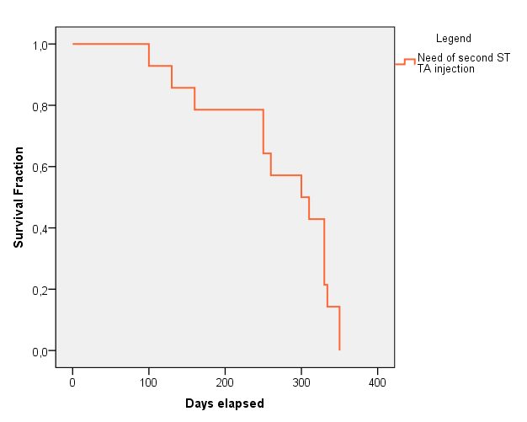

Figure 1. Kaplan-Meier estimation of global incidence of need of second ST TA injection. ST TA – Sub-tenon’s Triamcinole Acetonide