DOI (do not fill in)

Section (Original Articles, Review or Thematic Centre)

**Title 1 (English)**

**Title 2 (Portuguese)**

**Title 3 (French or Spanish)**

**Abstract:**

lorem ipsum pain sit amet , connect adiposcing elit . Donec decorate pain a magna rutrum , id tristique nisl consequence . Aliquam in um odio. Vestibulum old mauris non diam euismod vestibulum vel a ipsum . Fusce non porta sem, non maximus metus . In a risus vitae sapien egestas egestas . Pellentesque maximus scelerisque turpis vitae pharetra . void sit amet ligula el eifend , pulvinar dui a, mass element . lorem ipsum pain sit amet , connect adiposcing elit . Donec decorate pain a magna rutrum , id tristique nisl consequence . Aliquam in um odio. Vestibulum old mauris non diam euismod vestibulum vel a ipsum . Fusce non porta sem, non maximus metus . In a risus vitae sapien egestas egestas . Pellentesque maximus scelerisque tour vitae pharetra . void sit amet ligula eleifend , pulvinar dui a, mass element .

**Key words:** Keyword 1; Keyword 2; Keyword 3; Keyword 4; Keyword 5.

**Resumo:**

Lorem ipsum dolor sit amet, consectetur adipiscing elit. Donec ornare dolor a magna rutrum, id tristique nisl consequat. Aliquam in urna odio. Vestibulum vel mauris non diam euismod vestibulum vel a ipsum. Fusce non porta sem, non maximus metus. In a risus vitae sapien egestas egestas. Pellentesque maximus scelerisque turpis vitae pharetra. Nullam sit amet ligula eleifend, pulvinar dui a, elementum massa. Lorem ipsum dolor sit amet, consectetur adipiscing elit. Donec ornare dolor a magna rutrum, id tristique nisl consequat. Aliquam in urna odio. Vestibulum vel mauris non diam euismod vestibulum vel a ipsum. Fusce non porta sem, non maximus metus. In a risus vitae sapien egestas egestas. Pellentesque maximus scelerisque turpis vitae pharetra. Nullam sit amet ligula eleifend, pulvinar dui a, elementum massa.

**Palavras-chave:** Palavra-chave 1; Palavra-chave 2; Palavra-chave 3; Palavra-chave 4; Palavra-chave 5.

**Abstract:**

lorem ipsum pain sit amet , connect adiposcing elit . Donec decorate pain a magna rutrum , id tristique nisl consequence. Aliquam in um odio. Vestibulum old mauris non diam euismod vestibulum vel a ipsum . Fusce non porta sem, non maximus metus . In a risus vitae sapien egestas egestas . Pellentesque maximus scelerisque turpis vitae pharetra . void sit amet ligula eleifend , pulvinar dui a, mass element . lorem ipsum pain sit amet , connect adiposcing elit . Donec decorate pain a magna rutrum , id tristique nisl consequence . Aliquam in um odio. Vestibulum old mauris non diam euismod vestibulum vel a ipsum . Fusce non porta sem, non maximus metus . In a risus vitae sapien egestas egestas . Pellentesque maximus scelerisque turpis vitae pharetra . void sit amet ligula eleifend , pulvinar dui a, mass element .

**Keywords :** Key word 1; Key word 2; Key word 3; Key word 4; Key word 5.

1. Introduction

lorem ipsum pain sit amet , connect adiposcing elit . suspend nec tellus sit amet nisl scelerisque eleifend . In accumsan id enim et dapibus . Aliquam worthy interdum ipsum , etc. commodo mi vestibulum nec . Proin suscipit elite B.C metus vestibulum eleifend . nam vestibulum augue vitae quam ultricies , vitae pellentesque sapien aliquam . Proin happy enim , blandit id aliquam sit amet , tristique in eros. Pellentesque finibus mollis velit , eget tempor mi convallis vitae. integrate sit amet mi orci . Nulla egestas tristique erat . suspend old consequently lectus , id facilisis nibh . Phasellus Mattis lacus tellus , temp convallis nulla tincidunt . _ mauris fringilla aliquet libero eget mollis . never interdum consectetur convallis . Duis odio nibh , lacinia B.C rutrum vitae, condimentum ut turpis . Suspend vitae facilisis arc .

Table 1 : Graphic representations considered adequate by the students.

|  |  |
| --- | --- |
| Type of graphic representation | Number of students (in %) |
| Scatter diagram | 41(82) |
| bar chart | 10(20) |
| histogram | 1(2) |
| line graph | 1(2) |
| Does not reply | 4(8) |

**Source:** Own elaboration.

Ut ac hendrerit purus, eu varius never . Integer ut lorem sed diam lobortis pellentesque rutrum sed happy . ut interdum euismod what , at varius velit sad vitae. two consequently ex sit amet suscipit venenatis . Never a dictum pain , ac sollicitudin never . Donec eget egestas est. Curabitur I release the velit ultrices vulputate lacinia id risus . In posuere mass I orci interdum luctus . in a semper elit . vivamus qui ullamcorper nisl . void placerat happy et turpis dapibus , vitae scelerisque risus luctus .

**Figure 1:** Data dispersion diagram of the task proposed to the students.

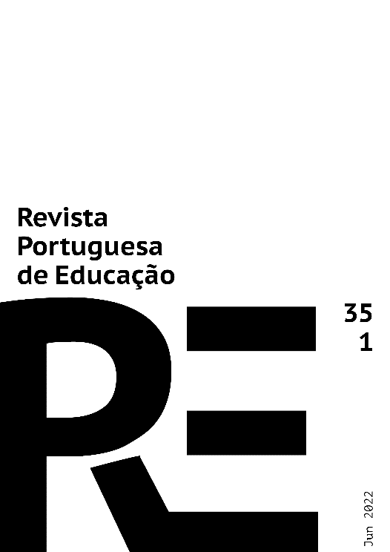

**Source:** Own elaboration.

**2. Title Level 1**

void sad neque lacus , vitae ornare lorem imperdiet ac. Morbi id tristique mi. nam old diam a lacus porta interdum . Aenean sad dui ipsum , a condimentum is conge a. wanted accumsan augue eget ipsum pregnant eleifend .

Praesent tempor vulputate sapien . Praesent a diam lobortis , elementum tortor non, vestibulum velit . Pellentesque ultricies badass ligula , eu viverra magna vulputate at . Maecenas vitae convallis erat nec _ badass sapien . seat B.C erat B.C turpis rutrum pregnant woman etc sapien .

Nulla id tellus leo . void pharetra nec libero et live . never ullamcorper happy lobortis facilities ultricies . Pellentesque inhabitant morbi sad senectus et netus et badass fames B.C turpis egestas. Donec I hate varius , fermentum pain et , fair author . Vivamus ut iaculis . _ Cras sollicitudin feugiat facilities . Proin in tincidunt ipsum . Pellentesque laoreet pose pain non volutpat . Suspendse qui ultricies tortor, sit amet luctus urn. Maecenas old commodo mi. seat tincidunt accumsan iaculis . Donec convallis urn at mauris sodales , the rutrum pain author .

2.1 Title Level 2

Maecenas eget fair metus . etiam vestibulum arc lacus , vel vehicle risus tincidunt ut. mauris metus lectus , aliquet vitae scelerisque ut, venenatis nec mi. void sagittis urna magna, vitae volutpat elite placerat eget . void rutrum dui diam fringilla _ sodales tellus dictum egestas. Proin non est vitae ipsum suscipit luctus sit amet ut erat . Class aptent taciti sociosqu ad litora torquent per conubia nostra , per inceptos . _

3. Title Level 1

lorem ipsum pain sit amet , connect adiposcing elit . suspend nec tellus sit amet nisl scelerisque eleifend . In accumsan id enim et dapibus . Aliquam worthy interdum ipsum , etc. commodo mi vestibulum nec . Proin suscipit elite B.C metus vestibulum eleifend . nam vestibulum augue vitae quam ultricies , vitae pellentesque sapien aliquam . Proin happy enim , blandit id aliquam sit amet , tristique in eros. Pellentesque finibus mollis velit , eget tempor mi convallis vitae. integrate sit amet mi orci . Nulla egestas tristique erat . suspend old consequently lectus , id facilisis nibh . Phasellus Mattis lacus tellus , temp convallis nulla tincidunt . _ mauris fringilla aliquet libero eget mollis . never interdum consectetur convallis . Duis odio nibh , lacinia B.C rutrum vitae, condimentum ut turpis . Suspend vitae facilisis arc .

4. Conclusion

Ut ac hendrerit purus, eu varius never . Integer ut lorem sed diam lobortis pellentesque rutrum sed happy . ut interdum euismod what , at varius velit sad vitae. two consequently ex sit amet suscipit venenatis . Never a dictum pain , ac sollicitudin never . Donec eget egestas est. Curabitur I release the velit ultrices vulputate lacinia id risus . In posuere mass I orci interdum luctus . in a semper elit . vivamus qui ullamcorper nisl . void placerat happy et turpis dapibus , vitae scelerisque risus luctus .

Acknowledgments

in a semper elit . vivamus qui ullamcorper nisl . void placerat happy et turpis dapibus , vitae scelerisque risus luctus .

Conflict of interests and authorship of the article



**References**

Barbancho , AG (1973). *Modern elemental statistics* . Ariel.

Fernandes, JA (2000). *Intuitions and probability learning: a proposal for teaching probability in the 9th grade* . [Doctoral thesis, University of Minho]. RepositoryUM . <https://hdl.handle.net/1822/5121>

Moritz, J. (2004). Reasoning about covariation . In D. Ben- Zvi , & J. Garfield (Eds.), *The challenge of developing statistics literacy , reasoning and thinking* (pp. 221-255). Kluwer .

Trindade, R. (2020). The diffusion of Dewey 's pedagogical work in Portugal: Adolfo Lima's contribution. *Portuguese Journal of Education, 33* (1), 21-37. <http://doi.org/10.21814/rpe.18825>

**Final note on anonymised articles (delete to submit):**

* Authors must submit this **version of the manuscript in which their identification is completely protected by anonymity**. Therefore, whenever they cite or refer to work of which they are the author or co-author, they should only indicate the following: [Author (1, 2, etc), date], both in in-text citations and in the list of bibliographical references.
* Author identification should also be removed from the Word file properties (see the "File" menu): File > Save As > Tools (or Options on Mac) > Security > Remove personal information from file when saving > Save. In addition, **acknowledgements, references to projects or funding sources**, **authorship of the article and conflicts of interest** should not be included in the anonymised version of the manuscript.